NOTE: BEFORE INVESTING -> MAKE SURE CHECK FOR LARGE AND MID CAP , WHICH TO CHOOSE ACTIVE OR NIFTY50 , OR ACTIVE OR NIFTY MIDCAP 150. SINCE WE HAVE TRADE OFF OF OBSERVING AND MONITORING EXPENSE RATIO VS BOUGHT AND FORGET.

Lets Say 20 Lakh Lumpsum amount in bank.

Note:
- Ignoring health insurance and term life etc are already taken care of.
- Ignoring Expenses.
- Assume monthly expense: 30%, ( Need to invest 70% )

1. Emergency Funds: 12*Monthly expense ( if 50k, then -> 6 lakh )
- Where to park: ( safety highest priority, liquidity , return. )
  - break into multiple small FD:
  - keep 80% mom account, 20% self.
2. Opportunity/Parking Funds: 10% => 2Lakh ( liquidity priority, then safety , then return)
- Where to park: do I really need this ? if so what should be stratedy ? like sip or lump sum or if it took more than 3 months what then ?
  - Keep this as a low priority.
3. Retirement: As of now keep PF, but later once I got experience might change to ELSS ( since good return ) [ 20% of Salary , SIP ]
4. [1-3Y]:
- Tax free FD.
- Arbitrage: Kotak Arbitrage Fund Direct Growth [ 1Y = 6.7 ]
- Equity saving [>=3 ]: ICICI Prudential Equity Savings Fund Direct Growth [ 3Y = 7.2, but other gave 11-14% ]
5. [3-5Y]:
- ICICI Prudential Equity Savings Fund Direct Growth [ 3Y = 7.2, but other gave 11-14%]
- HDFC Balanced Advantage Fund Direct Growth. [ 3Y = 13.8% ]
  - Pending check deep dive with icici
- ICICI Prudential Multi Asset Fund Direct Growth. [ 3Y = 16% , other gave > 20% ]
  - Pending: Deep comparison ( with quant and nippon )

6. [5-10Y]:
- SBI Equity Hybrid Fund Direct Plan Growth [ 5Y = 11.5% ]
  - compare deep with ICICI Prudential Equity & Debt Fund Direct Growth [ 5Y = 16.47% ]
- UTI Nifty 50 Index Fund [ 5Y - 9.68 ] , [ 3Y - 8.9 ]
- Kotak Nifty Next 50 Index Direct Growth [ 5Y - 14.17% ] [ 5Y - 19% ]
  - or ICICI Prudential
- ICICI Prudential Large Cap Fund Direct Growth [5Y = 13.39%]
  - or check with nippon
- Invesco India Large & Mid Cap Fund Direct Growth
  - deep dive with nippon [5Y = 18.22%]
- HDFC Mid Cap Fund Direct Growth [5Y = 20.68%]
  - deep dive with nippon
- Motilal Oswal Nifty Midcap 150 Index Fund Direct Growth [ 5Y = 17.74% ]
  - deep dive with nippon
- Nippon India Small Cap Fund Direct Growth [ 5Y = 20.00% ]
  - deep dive with bandhan ( good return )
- HDFC Nifty Smallcap 250 Index Fund Direct Growth, [ have only 3Y= 17.34% ]
  - deep dive with nippon
- HDFC Flexi Cap Direct Plan Growth [ 5Y= 18.66% ]
  - deep dive with PP and quant ( good return )
- DSP Nifty 50 Equal Weight Index Fund Direct Growth [ 5Y = 13.86% ]
  - Keeping this on hold ( smart beta for now )
- UTI Nifty 500 Value 50 Index Fund Direct Growth [ have only 3Y= 26.5% ]
  - Keeping this on hold ( smart beta for now )
- UTI Nifty200 Momentum 30 Index Fund Direct Growth [ 5Y= 10.85% ]
  - Keeping this on hold ( smart beta for now )
- SBI Focused Fund Direct Plan Growth
  - keeping this on hold, risky 30 stocks only. [ 5Y= 13.81% ]
  - deep dive with HDFC [ 5Y= 19.69% ] and ICICI

7. International ( keeping this on hold as of now , later )
- Motilal Oswal Nasdaq 100 FOF Direct Growth
- Kotak US Specific Equity Passive FoF Dir
- Motilal Oswal S&P 500 Index Dir

NOTE: Above percentage are the last 3 or last 5 years , not rolling etc.
What if lumpsum is >20 ?

---------------------------------------------------------------------------------------------------------------------------

  - 10% Gold ( No right now ) => 70/30
    - ICICI Prudential Multi Asset Fund Direct Growth
    - SBI Gold Direct Plan Growth

100% [ Long Term ]
- Starting:
  - 65% Large cap
    - Invesco India Large & Mid Cap Fund Direct Growth
    - HDFC Flexi Cap Direct Plan Growth
    - ICICI Prudential Large Cap Fund Direct Growth
    - Kotak Nifty Next 50 Index Direct Growth
    - UTI Nifty 50 Index Fund
    - ICICI Prudential Multi Asset Fund Direct Growth
  - 25% Small/Mid. ( major mid like close to 20-25%, small 5-10 )
    - HDFC Flexi Cap Direct Plan Growth
    - ICICI Prudential Multi Asset Fund Direct Growth
    - Invesco India Large & Mid Cap Fund Direct Growth
    - Motilal Oswal Nifty Midcap 150 Index Fund Direct Growth
    - HDFC Mid Cap Fund Direct Growth
    - Nippon India Small Cap Fund Direct Growth
    - HDFC Nifty Smallcap 250 Index Fund Direct Growth
This is what multi asset look like, mean what every i am trying to do large/mid/small/gold/debt they are doing all already.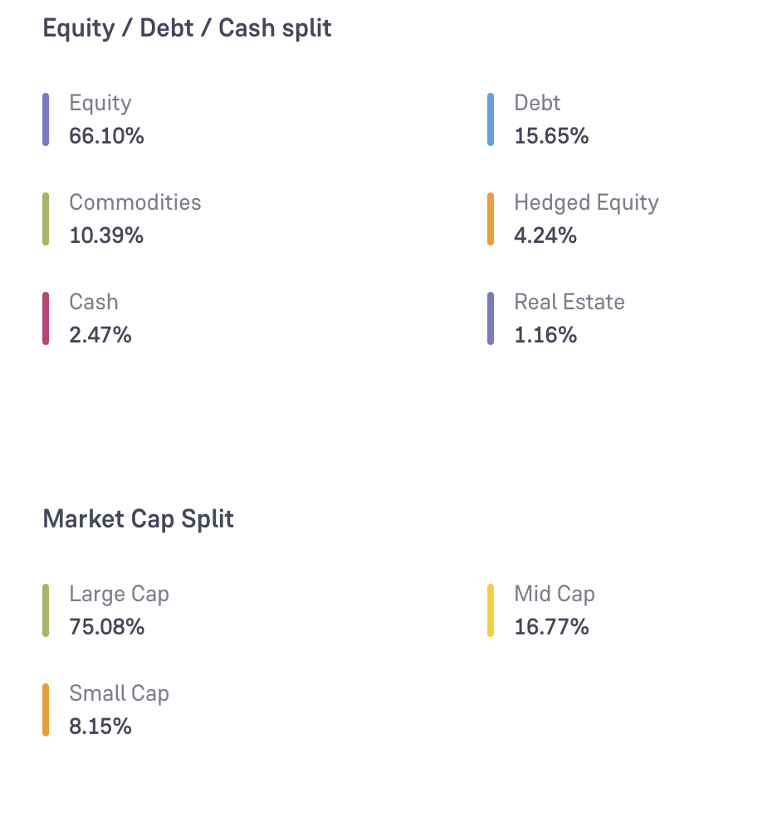
How to give 5-10% exposure to small.
https://www.youtube.com/watch?v=JkNVBoKPL5Q

Option:
- Multi asset allocation -> depend on them.
- 5.28% right now ( min can be 0 )
- Flexi cap
- hdfc -> 10-11%, PP -> 3.4%
- smallcap index
- here 100% in small caps, as per weightage.
- preferring active fund small cap than this.
- smallcap fund
- small cap must have 65% in small cap.
- and other max 35% can be in large,small,mid,debt etc. That means that can help in
downside but not the index.
- bandhan allows lump , but nippon not why so ???
- bandhan or nippon ?

How to give 15-20% exposure to mid.

Option
- HDFC Flexi Cap Direct Plan Growth
- ICICI Prudential Multi Asset Fund Direct Growth
- Invesco India Large & Mid Cap Fund Direct Growth
- Motilal Oswal Nifty Midcap 150 Index Fund Direct Growth
- HDFC Mid Cap Fund Direct Growth

As per past data only few active mid-funds are able to consistently beat nifty midcap 150index. Now the question is how to make sure that that active fund after 7-10 years will be among them ? ( hdfc is one of them but in will it in future no idea )

60-70% in large:

Option:
- ICICI Prudential Multi Asset Fund Direct Growth
- HDFC Flexi Cap Direct Plan Growth
- Invesco India Large & Mid Cap Fund Direct Growth
- ICICI Prudential Large Cap Fund Direct Growth
- Kotak Nifty Next 50 Index Direct Growth
- UTI Nifty 50 Index Fund

As per past data only few active largecap funds are able to consistently beat nifty50, now question is how to make sure that that active fund after 7-10 years will be among them ? ( icici is one of them but in will it in future no idea )

Top Bull Market India:
- https://ticker.finology.in/discover/solutions/indian-stock-market-biggest-bull-runs
Top Bear Market India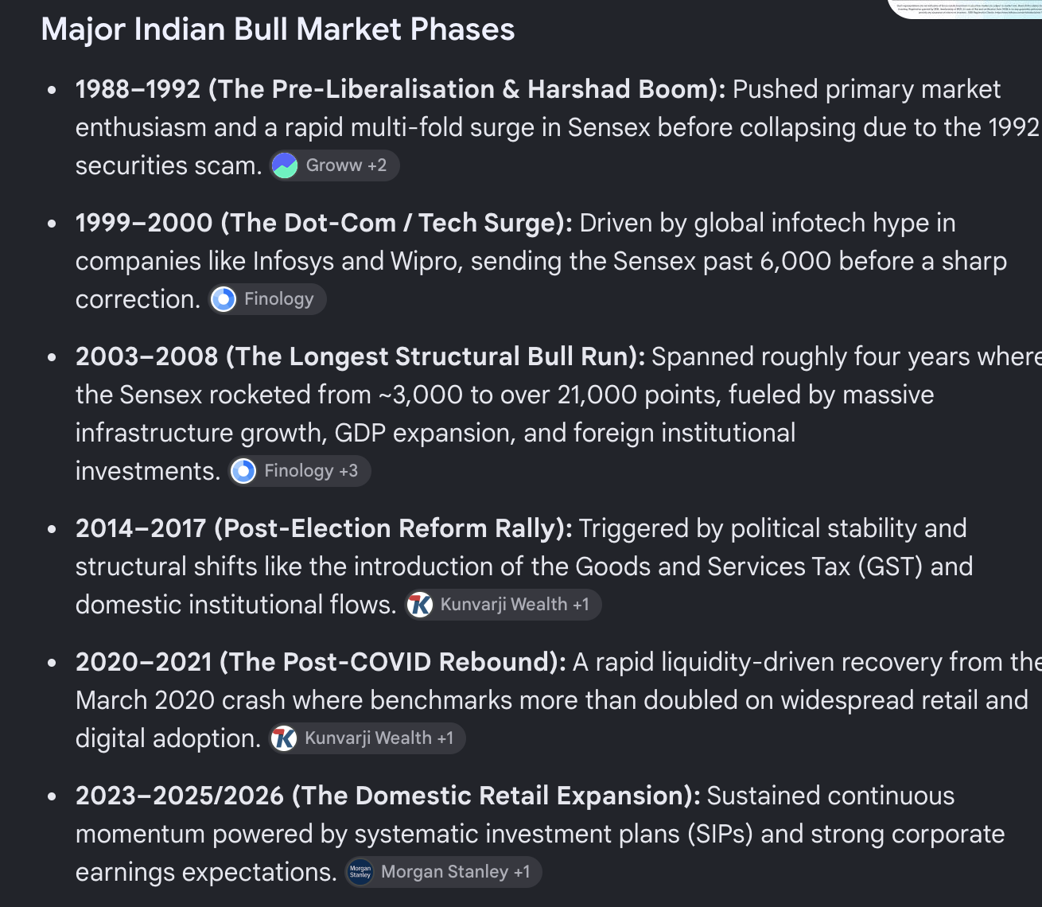
-

FINAL DECISIONS:

I should be a bit aggressive, since I have a long horizon.
maintaining both value and growth investing.
maintain large,mid,small,gold,debt etc.

1. For gold and debt. ( 30% ):
- We can pick multi asset -> ICICI its value+blend investing, got form fact sheet: ( Sunkaren Naren 2013 )
66% -> equity (75,17,8) => (50, 11.2 , 5.28)
10% -> commodities
15% -> deb

30%:
large -> 15%
Mid -> 3.2%
Small -> 1.56%
Commodities -> 3% ( after some time when it get require , might add more separately )
Debt -> 4.5%
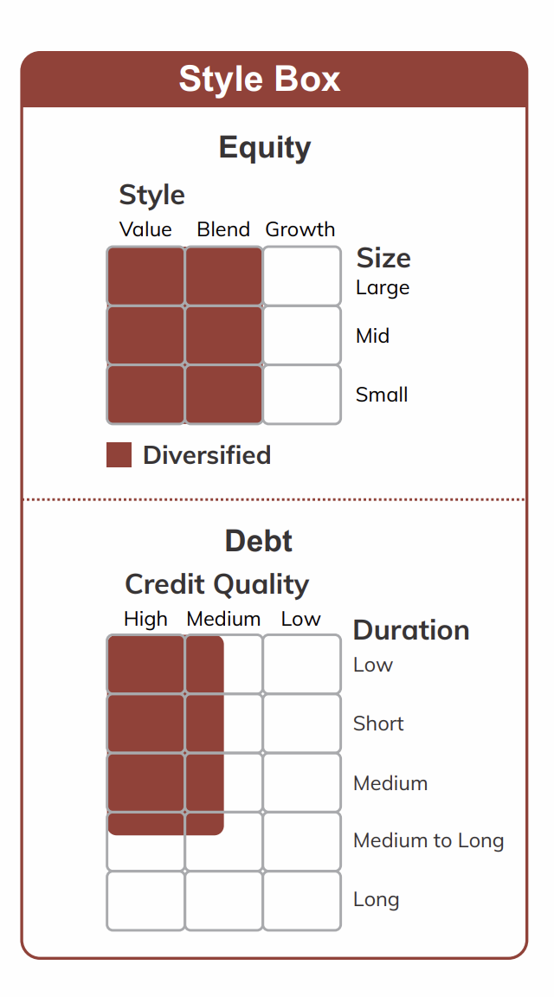
- AI must -> Deep dive into nippon vs icici multi asset vs quant + with icici balance/icici ( aggresive hybrid & dynamic ) , read their book, their investing etc deep dive. their fund manager, their philosophy, stocks etc etc. understand reason.
- avoiding balance icici ( dynamic allocation ) ,because ofl ess return not good for
long term, but its still interesting what did they change so that this and aggresive
hybrid have some much different after 2020
- and why SBI aggrestive hybrid return changes after 2020 as compare to icici.
- compare mutli asset icici, nipon , quant.
- check these for learning.
2. Since looking for long term , we can involve in mid bit more ~25-30% ( assume 5% other , give 20-25% here ) , might also have 30% large ( 9% )
- > better to take active funds so that they can have downside handling with large caps.
- > HDFC Mid Cap Fund Direct Growth (60-70, Chirag Setalvad, growth perspective)/ Nippon
-> Deep dive into hdfc mid cap and nippon , properly same as above. ( pick growth ) . last time check also index mid cap.
observe this as well , right now we are doing in active for future: what about future will it beat this in future ? what after 10 year this active fund vaishes ? 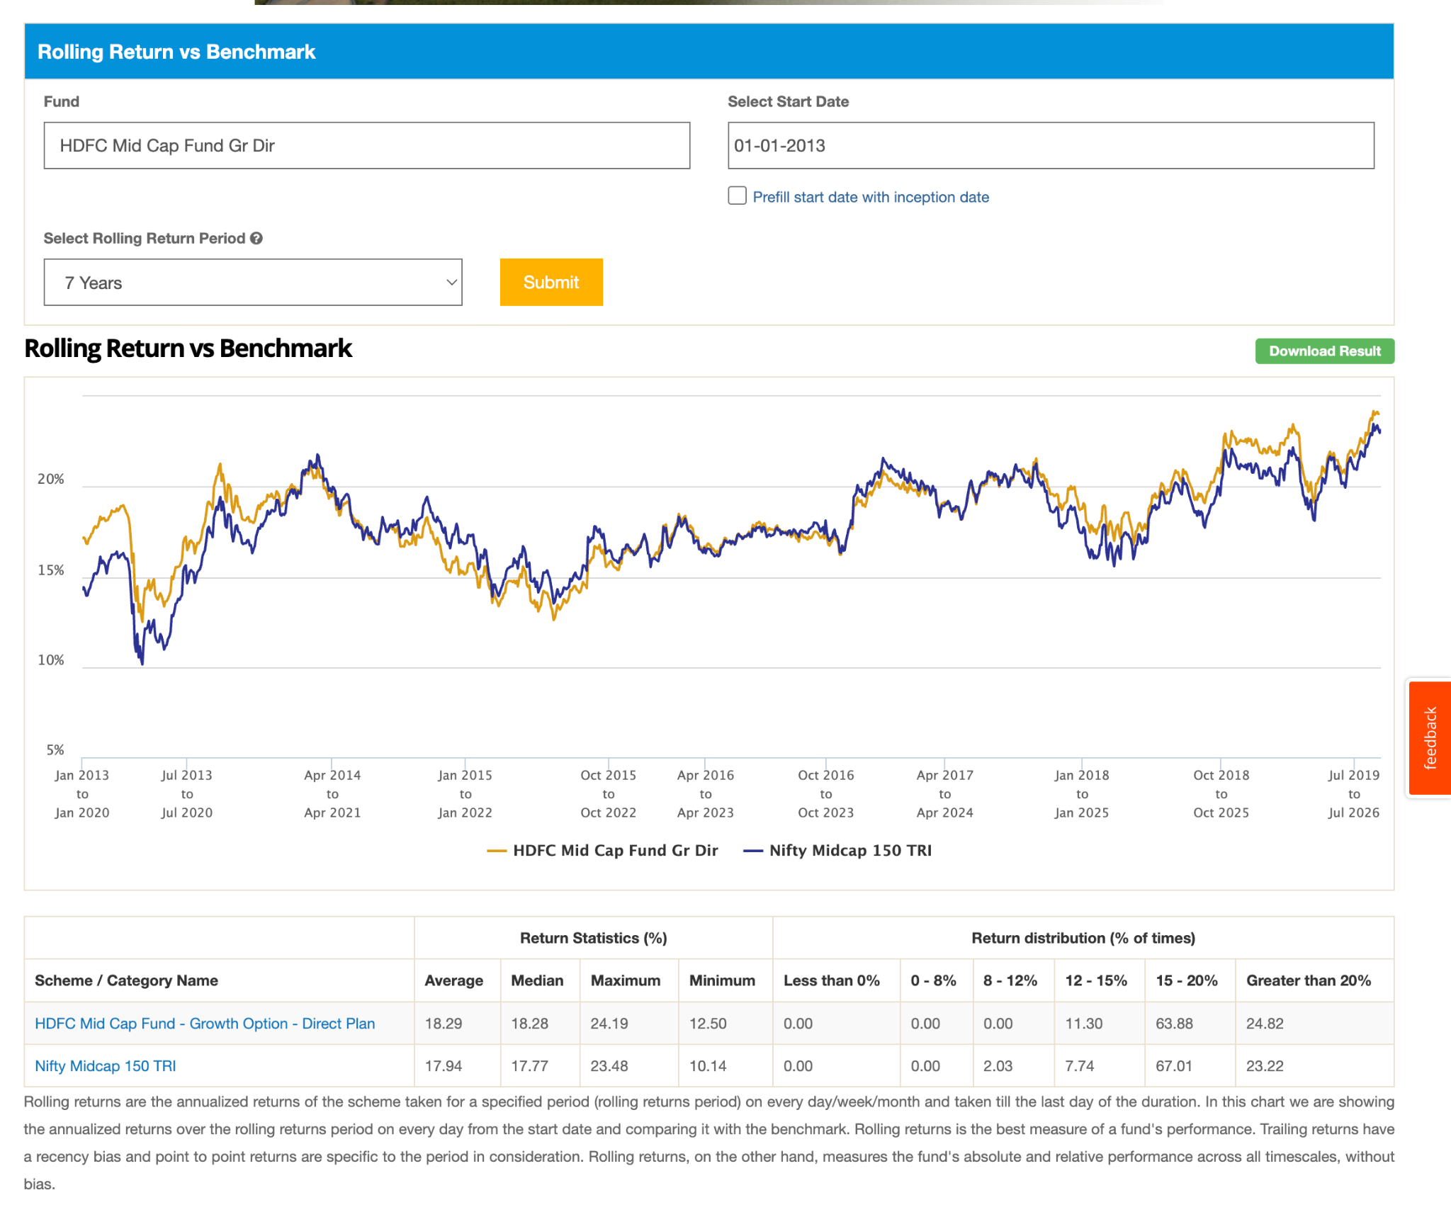
in 2020 mid was down 35-40% ( 10lakh => 6 lakh ) , what would you do here ?
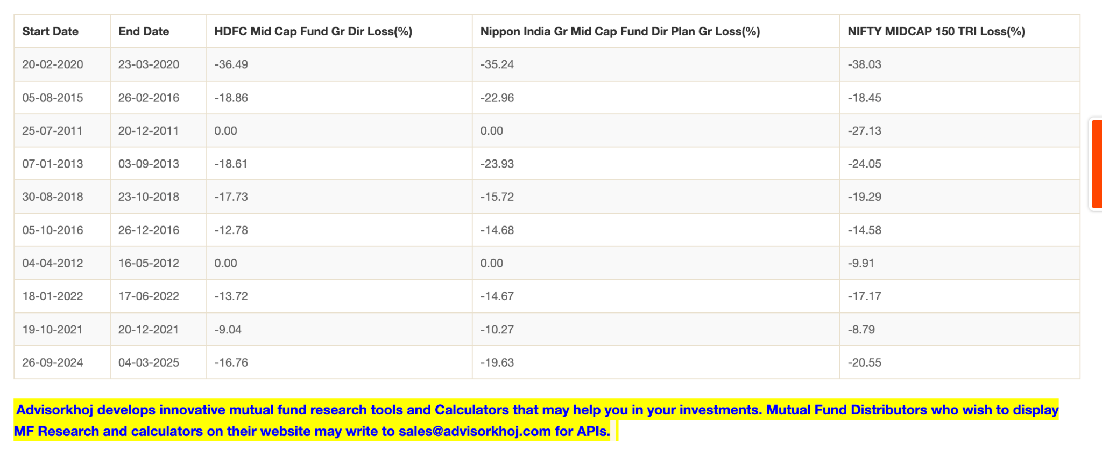

HDFC:
The aim of equity strategy will be to predominantly build a portfolio of mid-cap companies which have: a) reasonable growth prospects b) sound financial strength c) sustainable business models d) acceptable valuation that offers potential for capital appreciation

both have: Growth at Reasonable Price (GARP) style
hdfc have relative better fund manager i believe.
but we need to observer, if he go out in that case ?
as per current knowledge not have much idea about market, betting on fund manager and hdfc bet on more on health and tech , look better for me or else 50 50 :) and observe learn. -> https://www.valueresearchonline.com/stories/227909/5-most-consistent-mid-cap-funds-last-15-years/
https://www.valueresearchonline.com/learn/equity-funds/active-vs-passive-mid-cap-funds-which-one-should-you-choose/
what about mid cap index fund ? -> as of now ignoring. it has all year greaster because start ed late.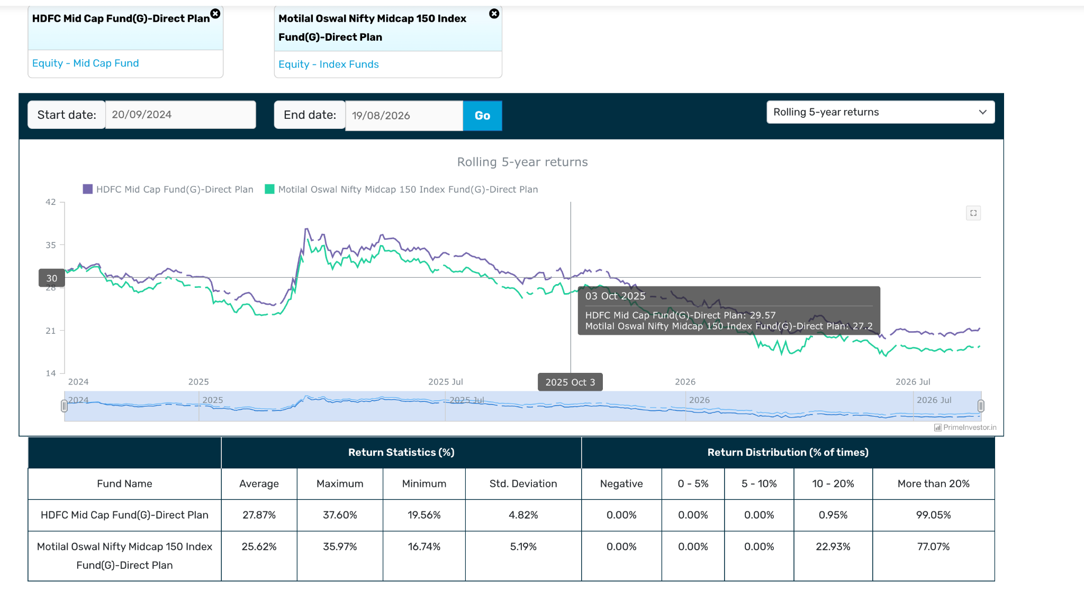

now 40-45% remain ( let say 40% )
Option: small cap, flexi, large cap.

3. Put 10% in a small cap. ( after some experience might increase more , avoid index here as well its bit tricy first of all 100% equity , second its depedent on formula but here company are bit risky. ) As per checking small cap index is not working that well , you can think index in mid or large , but bit tough in small
- can take active ( nippon , bandhan )
- deep dive into them, also compare with index also one last time.
- one thing noticed is that small fund give very good return also in one year, but they are small etc type, so after some experience you can play with that.
- also can invest in multiple funds in case of small/mid. since if you'll see many has good decent aum. else it would major proportion to one ( nippon has but other has diverse ), make sure to keep them in observant for future. that mean like we can invest in all three as well since they have only 10-15% common.

regularly check your fund with index fund or bench mark

Nippon: samir rach ( 2017 ) ( 2013 ) - current philosophy -> GARP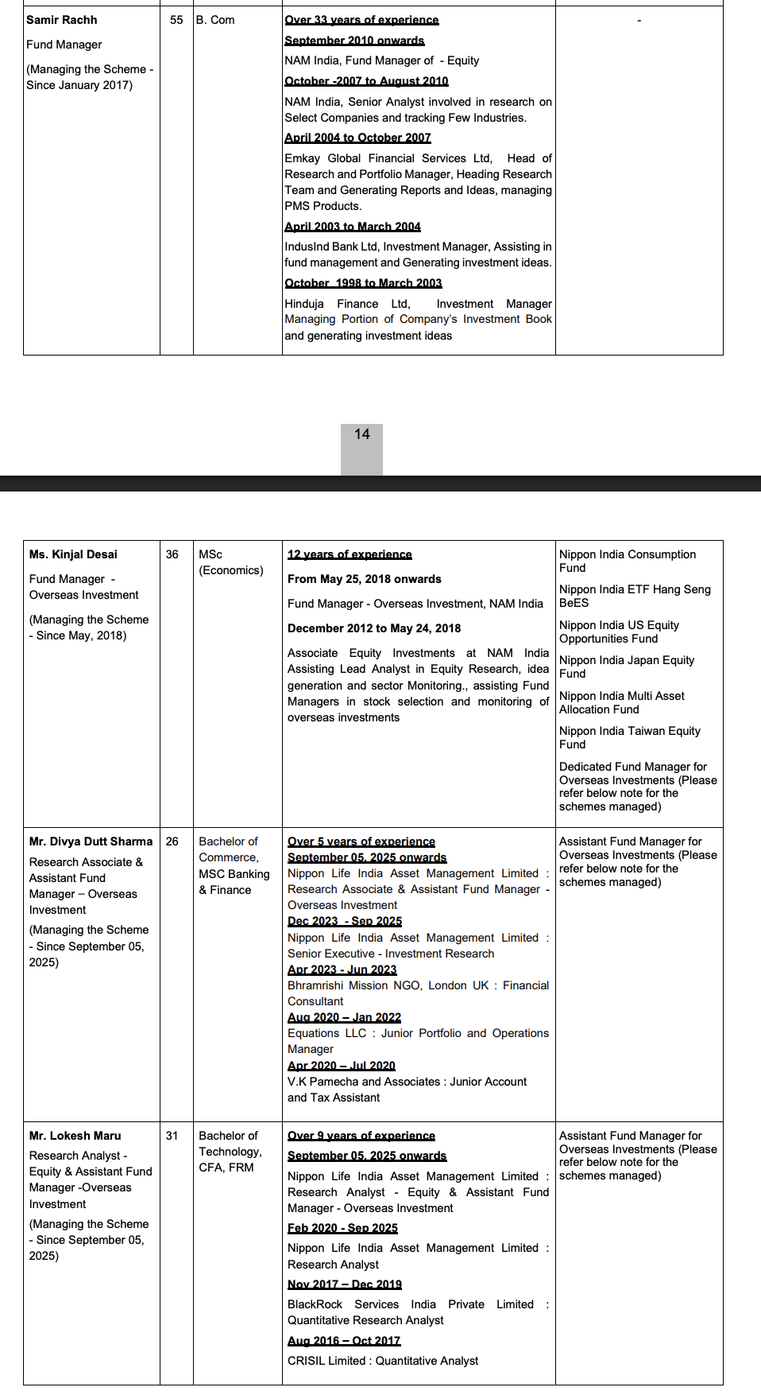
Bandhan: manish gunwami ( 2023 ) ( 2020 ) - min 3 year horizon - same stratedy garp
invesco: taher badshah/aditya khemani ( 2018 ) ( 2018 ) - baised toward growth + bottom up approach, which all do (The fund has a bias for ‘Growth’ stocks# and largely follows a fully invested approach (~ 95% invested) ( as a i saw in presentation also follow growth at reasonable valuation, -> not keep high cash ateast 95% equity + focussed stock like current only 68, while other 250+. ) invesco presntation is very good and details , can also pick out size of 250, ( 60% gorowth 40% value stock ) -> high p/e raito invesco -> mean more growth baised other two are ~27. top 20 is capturing 57%, means high dependent on 20 stocks. benchmark bse , bandhan also bse
- check one pont how much they fall in past so tha ti can be mentally ready
https://www.invescomutualfund.com/docs/default-source/presentations-pdf/invesco-india-small-cap-fund---july-2026.pdf?sfvrsn=5fd49fc2_0

in 2020 small cap index was down with 43% -> 10 lakh -> 5.7lakh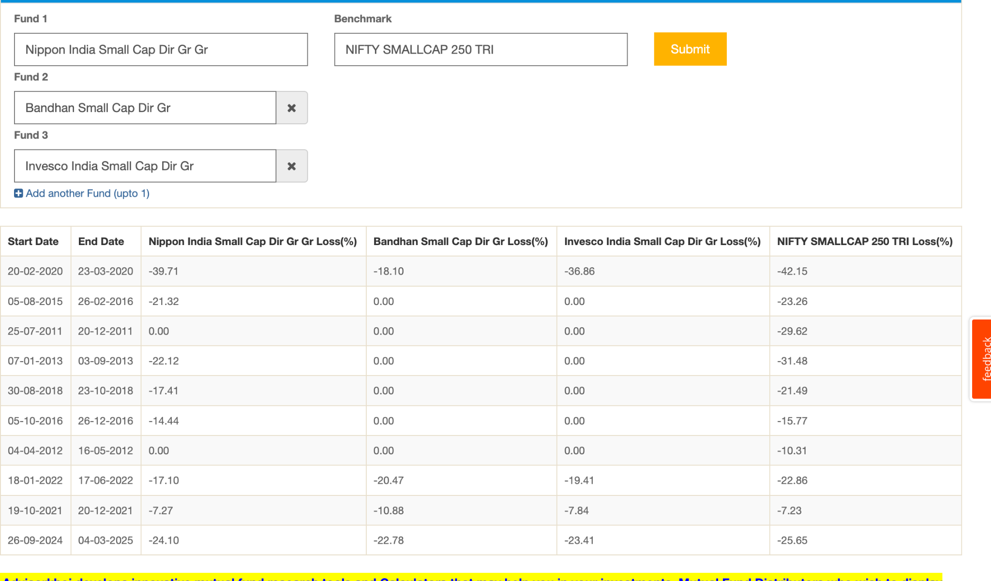

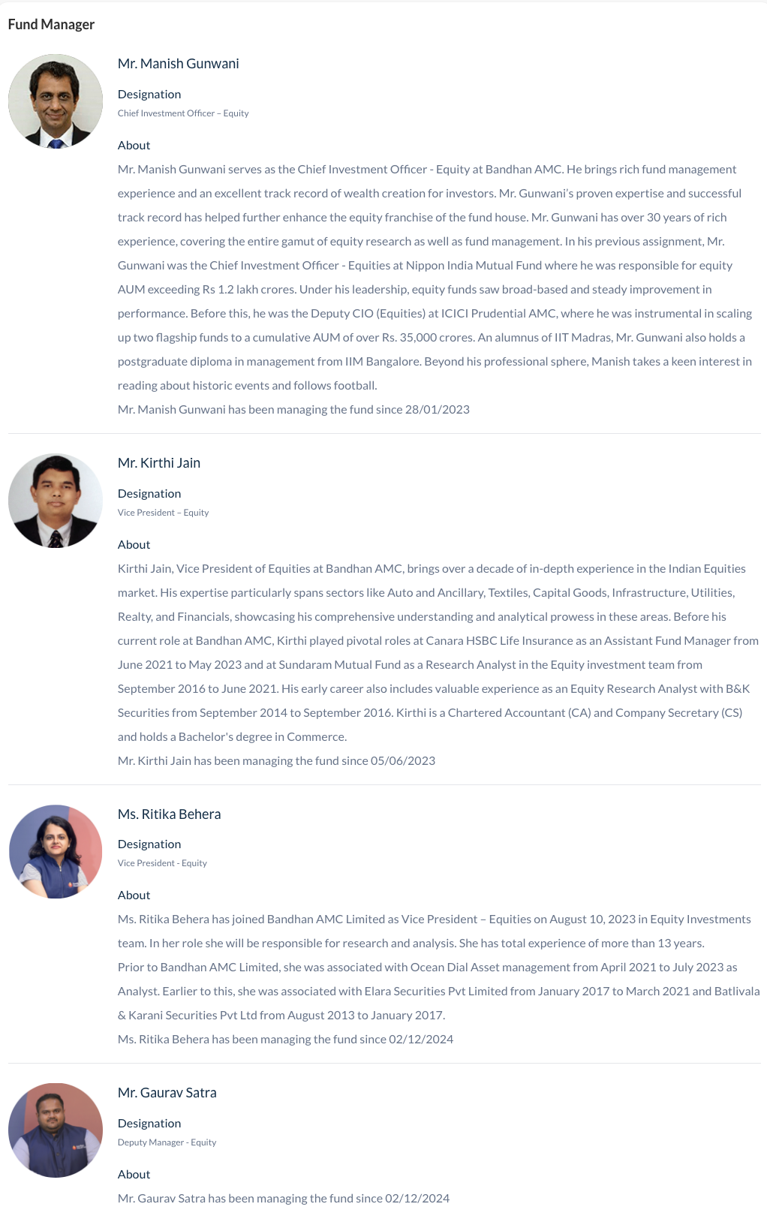

gut feeling -> invest in a strong fund manager team -> since small cap is too much company etc.

why should we invest in multiple small ( not too much not single one , 2-3 is good spot ) https://www.valueresearchonline.com/stories/226589/how-many-small-cap-funds-invest-in/
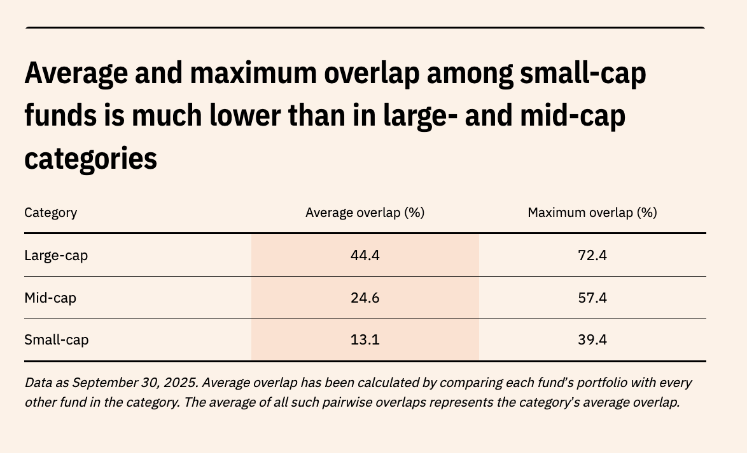
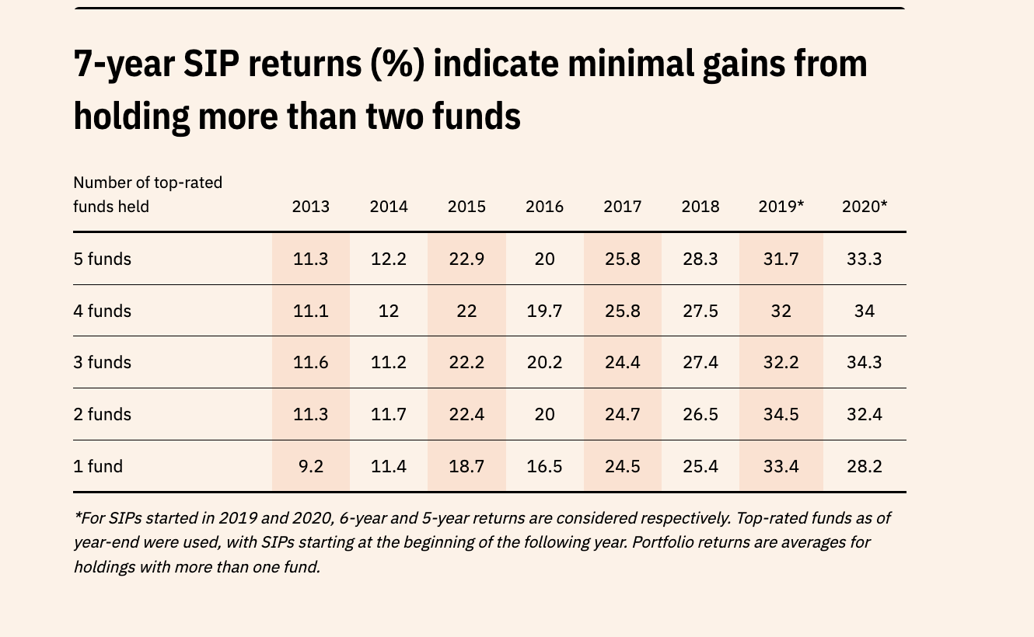
In the 2008 crash, the Nifty 100 TRI fell 61 per cent, while the Nifty Small-cap 250 TRI plunged an eye-watering 76 per cent. Small-caps aren’t quick to bounce back. Whenever the Nifty Small-cap 250 TRI fell more than 15 per cent from its peak, it took around 13 months to recover, compared with just 9 months for large-caps. The lesson is clear: going all-in on small-cap funds can be risky. A balanced approach—mixing high-risk, high-reward small-caps with steadier options like flexi-caps, which are largely dominated by large-caps—can help you ride out the storms while still capturing growth.

why not invest in small cap index fund: 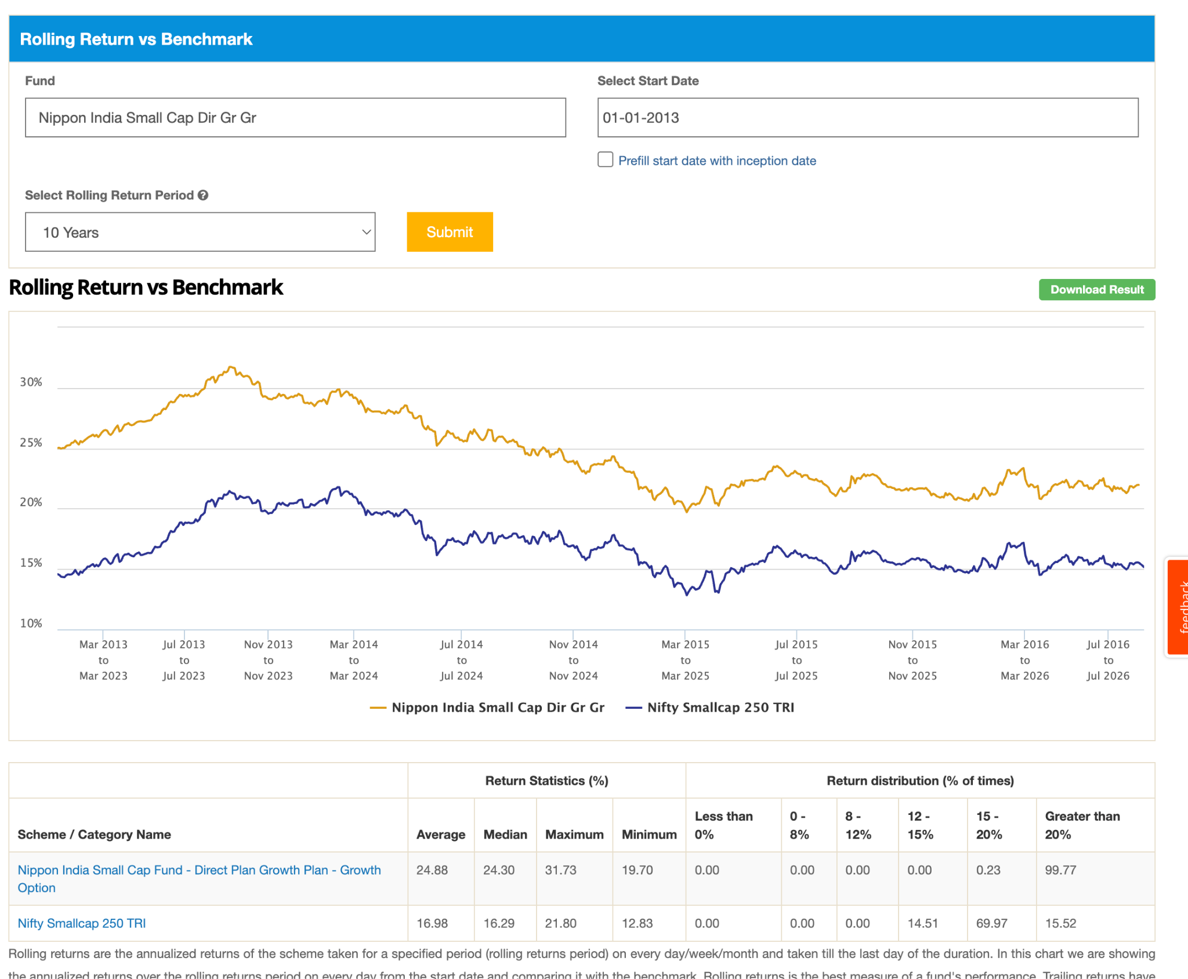
last two 2y didn't perform well small cap as category, but expect in future.
https://www.youtube.com/watch?v=lBFr3IIrYuo

- One fund i am going with nippon , because it is old it has seen ups and down more as compare to other category and working well , also high aum so liquidity , reliability more as compare to other.
- its hard to think like should we go with both or only one , as o now thinking to go with bandhan , but it has 16% overlap, invesco for most of time didn't perform well with nippon but currently dowing, lets keep, 40% nippon, 30% bandhan, 30% invesco ( betting on health care 2X as compare to other, nippon industry 2X as other) and will check this later. else, 60% nippon 40% bandhan ) . i am getting gut feeling invesco might drop in the future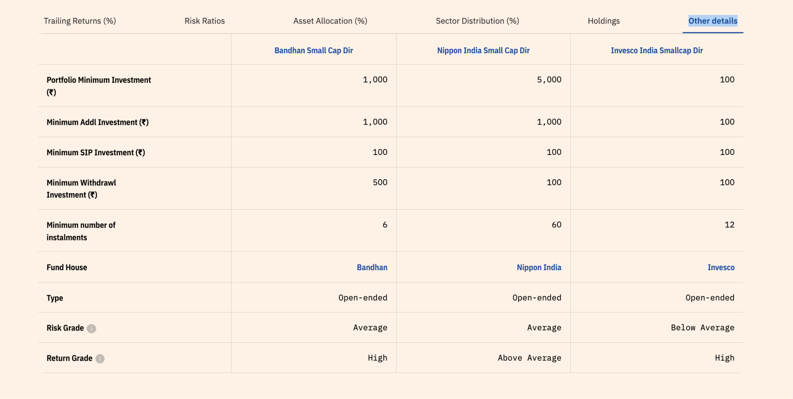. not able to decide.
- last 2 y return of bandhan -> 5, invesco - 11.2, nippon 2.21. so better invest in nippon and bandhan -> then see more and then invesco since already high.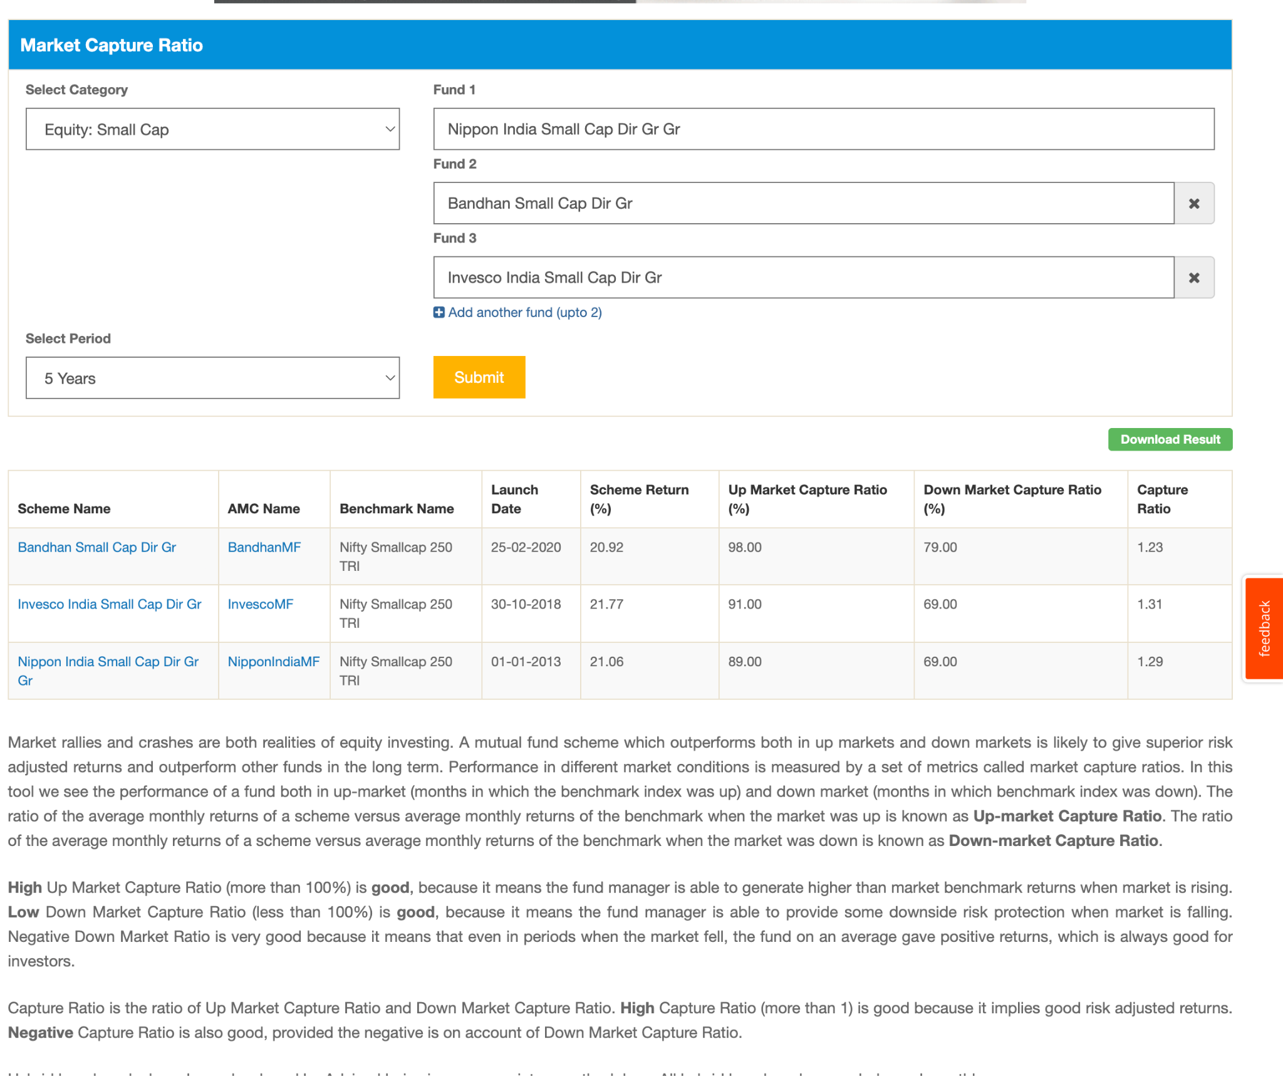

now total
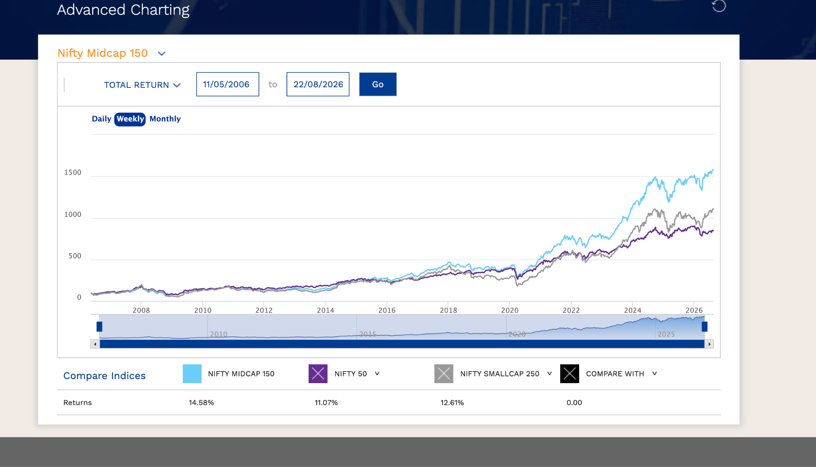

nifty 50 worst year:
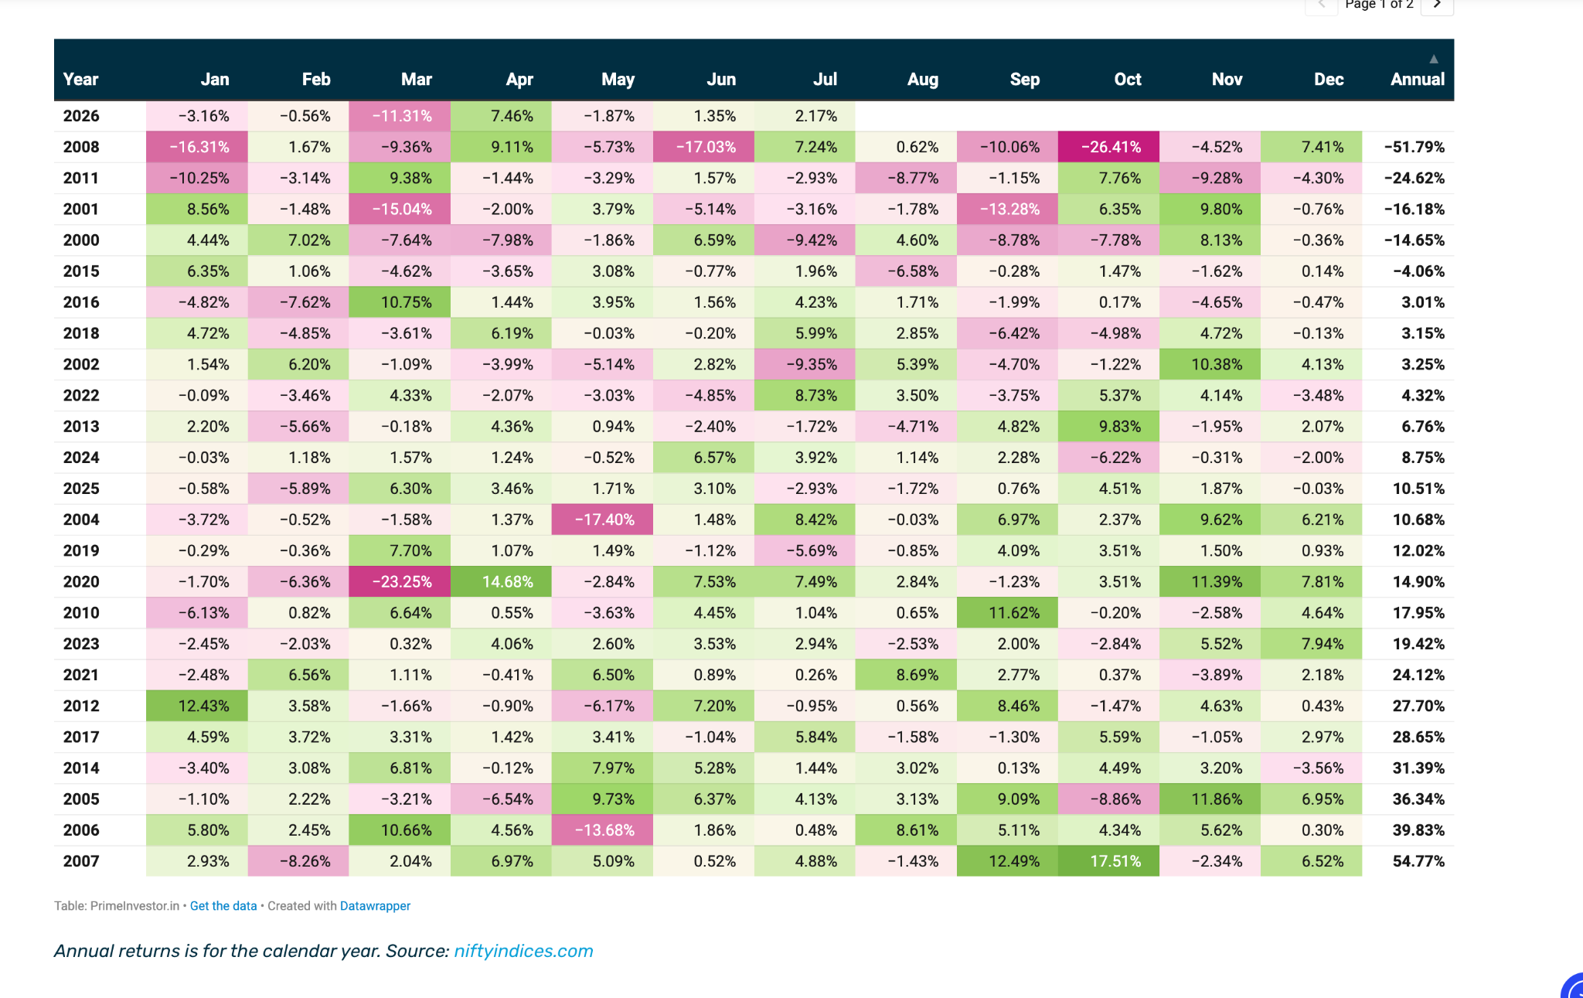

benmark comparision:
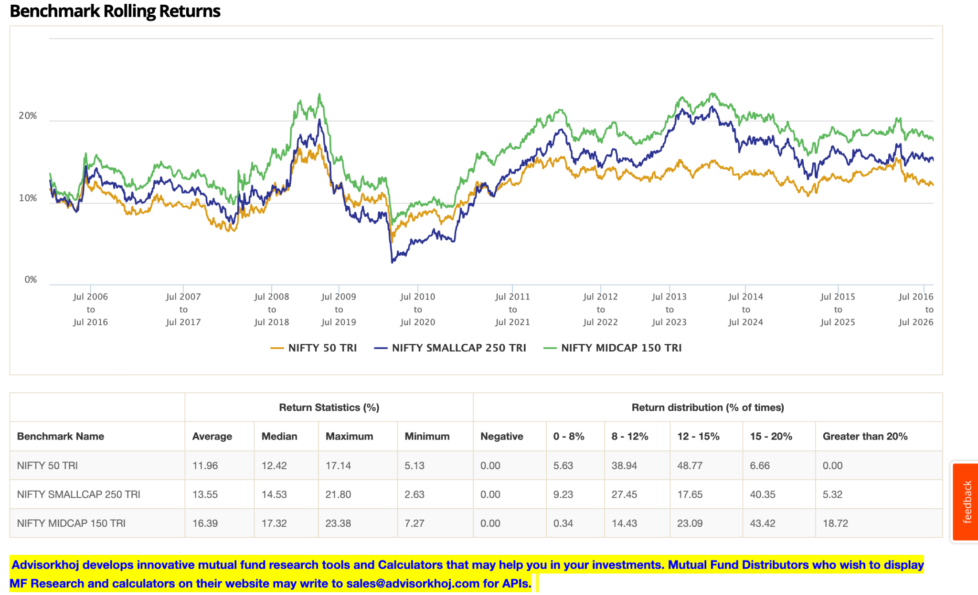

4. 30%
- Option -> large cap ( active ) , nifty 50, next 50, flexi.
- one flexi definitely lets put 15% in the flexi cap. Which one ? check hdfc, pp, quant. are they overlapping if so invest a/c to pass fund manager, if not how are they which one is suitable for out profile.
- 15% ->
-> for now next 50 avoid, already have mid cap.
-> again deep dive into nifty 50 and large cap.
-> if still confused, can do 50% 50% in both. else in any one of them after more experience might get more ideas.

- hdfc flexi: -> growth investing ( garp type below ss ), hdfc 3 year rolling return is better than pp 3year, pp 5 year is better than hdfc excep after 2020. on 10 yerar horizaon both are handsome ly beated benchmark pargraph more handsomely, they have 32% same portfolio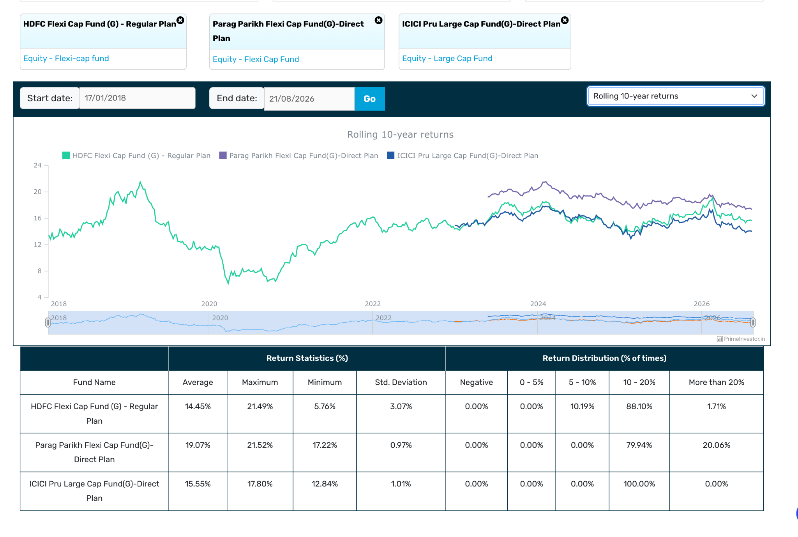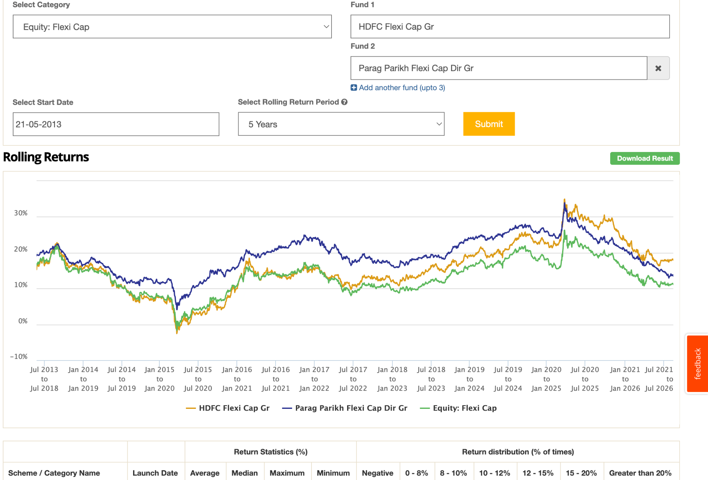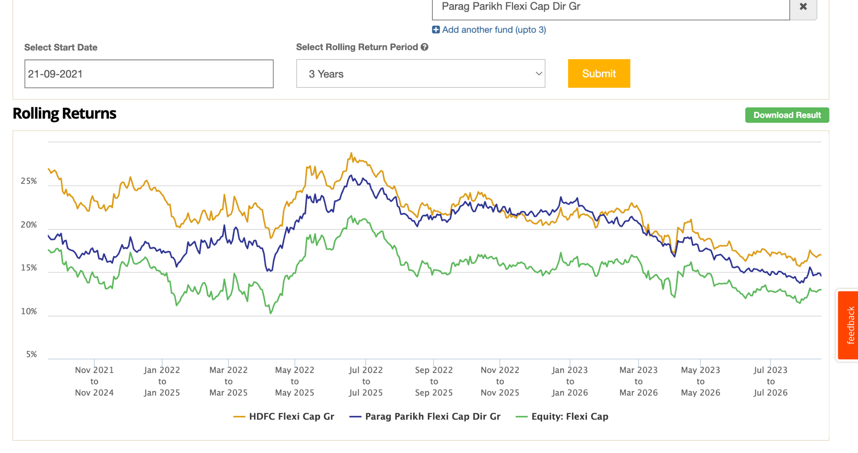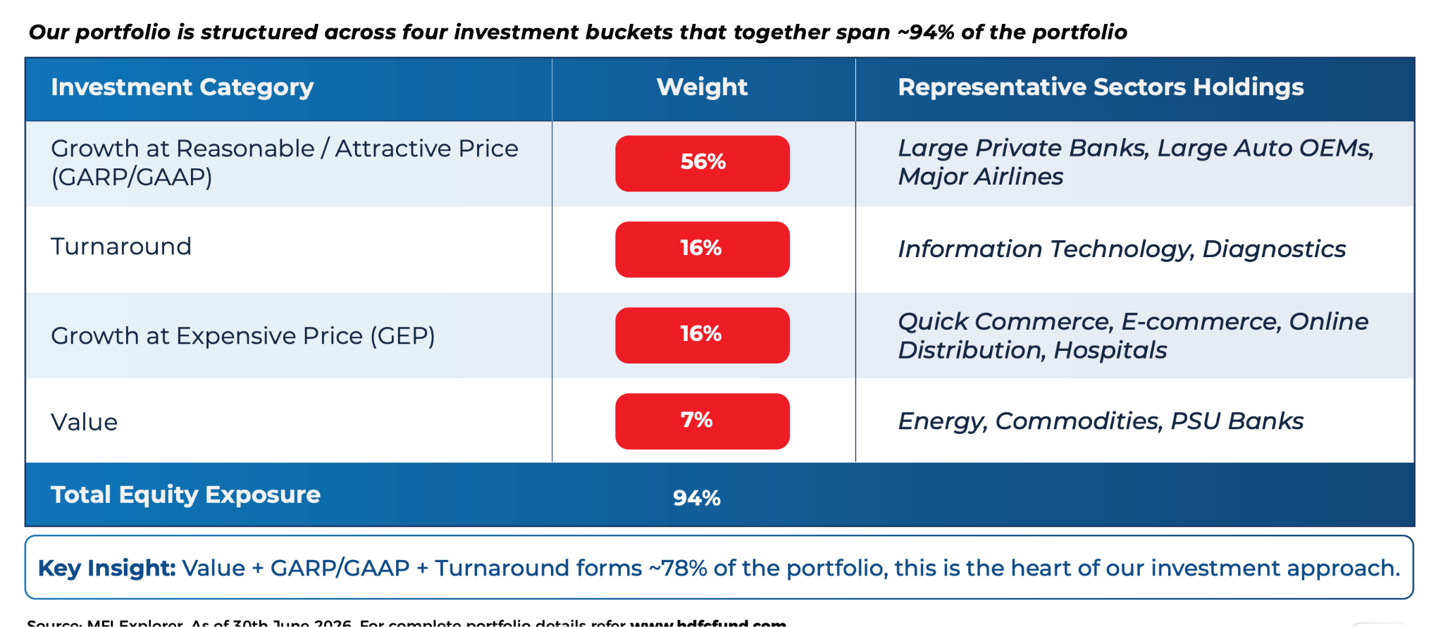e ) , fm: Amit Ganatra dhruv muttal, bit new fund managers roshi jain left.
- pp flex: -> value investing/blend -> process: ( Buying securities at a discount to intrinsic value will help to create value for investors. Our investment philosophy is to invest in such value stocks. ) , fm: rajeev thakkar https://amc.ppfas.com/schemes/investment-process/?utm_source=chatgpt.com

- UTF nifty 50: out of below two going with icici large cap right now ( growth investing ) currently 1y -> -1.5 so good time to invest.
- icici large cap, definitely out perfomaing nifty 50 since long time only in covid went bit low else alwasy more. 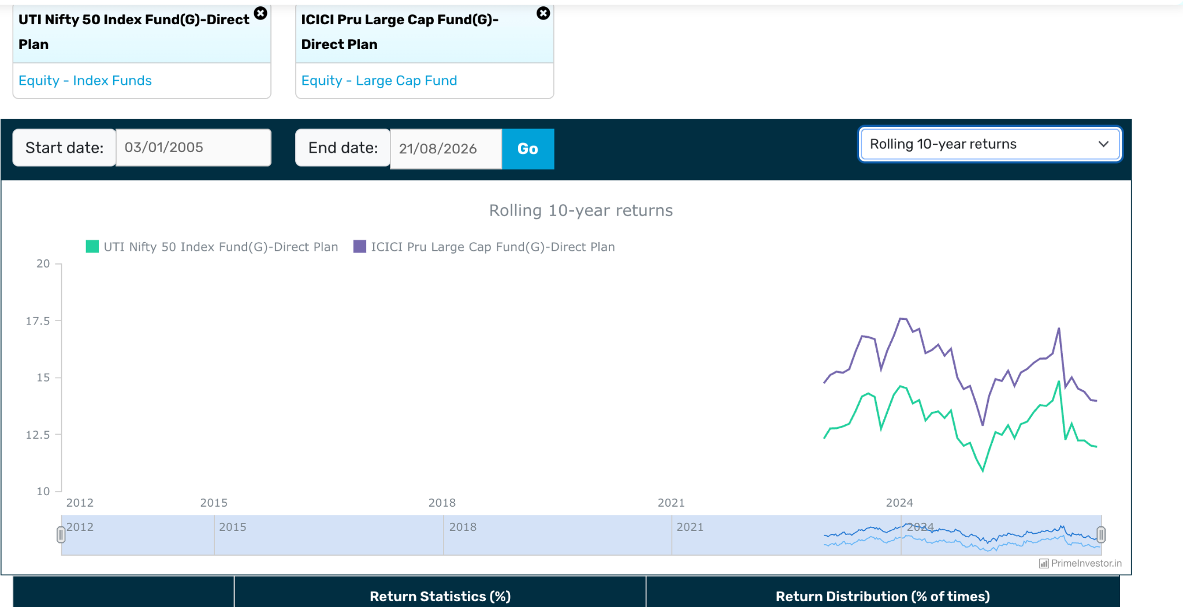

50% overlapping: so can't buy both, icici large cap aum is 4x. , sankaran naren handling this top fund manager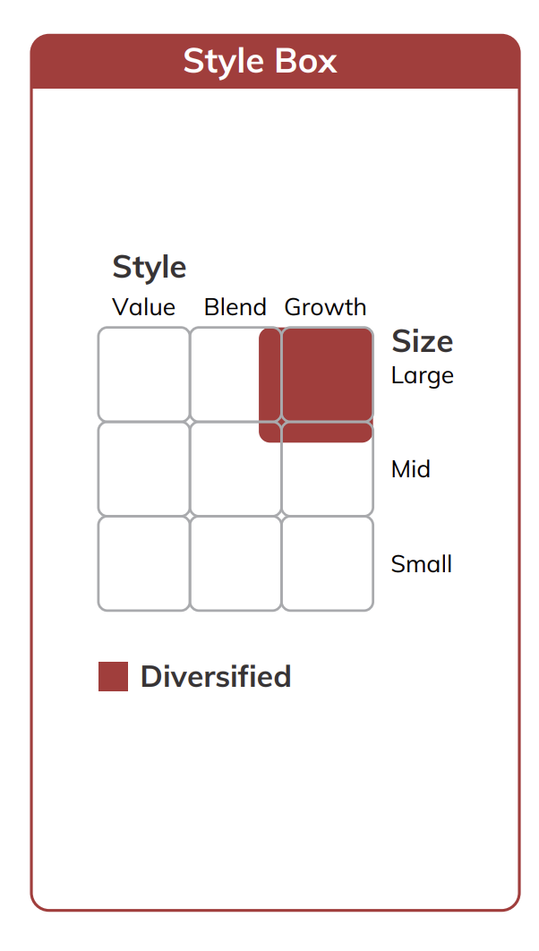 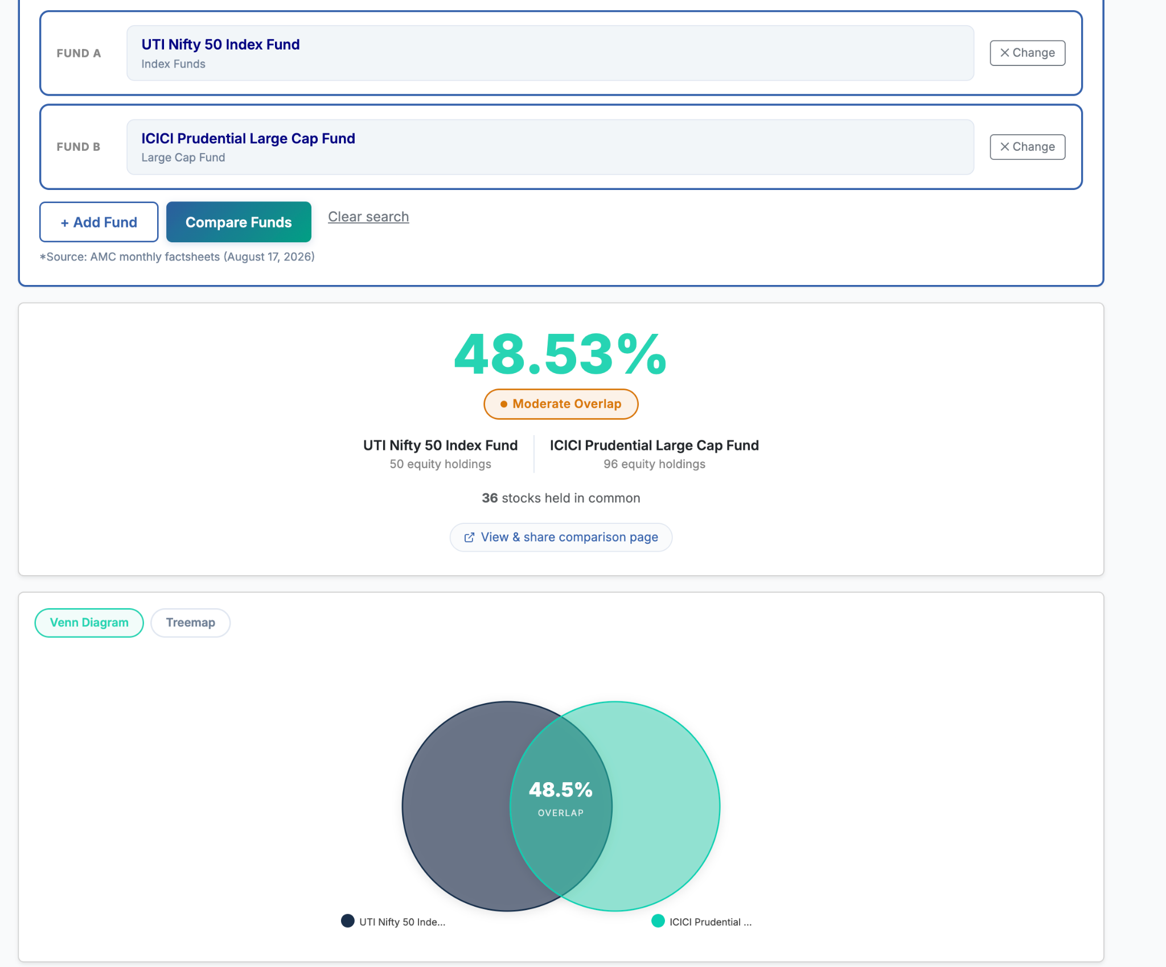
- icic multi asset: as of now ignore , will wait for gold to drop or if i find myself in position to invest in gold then will do.
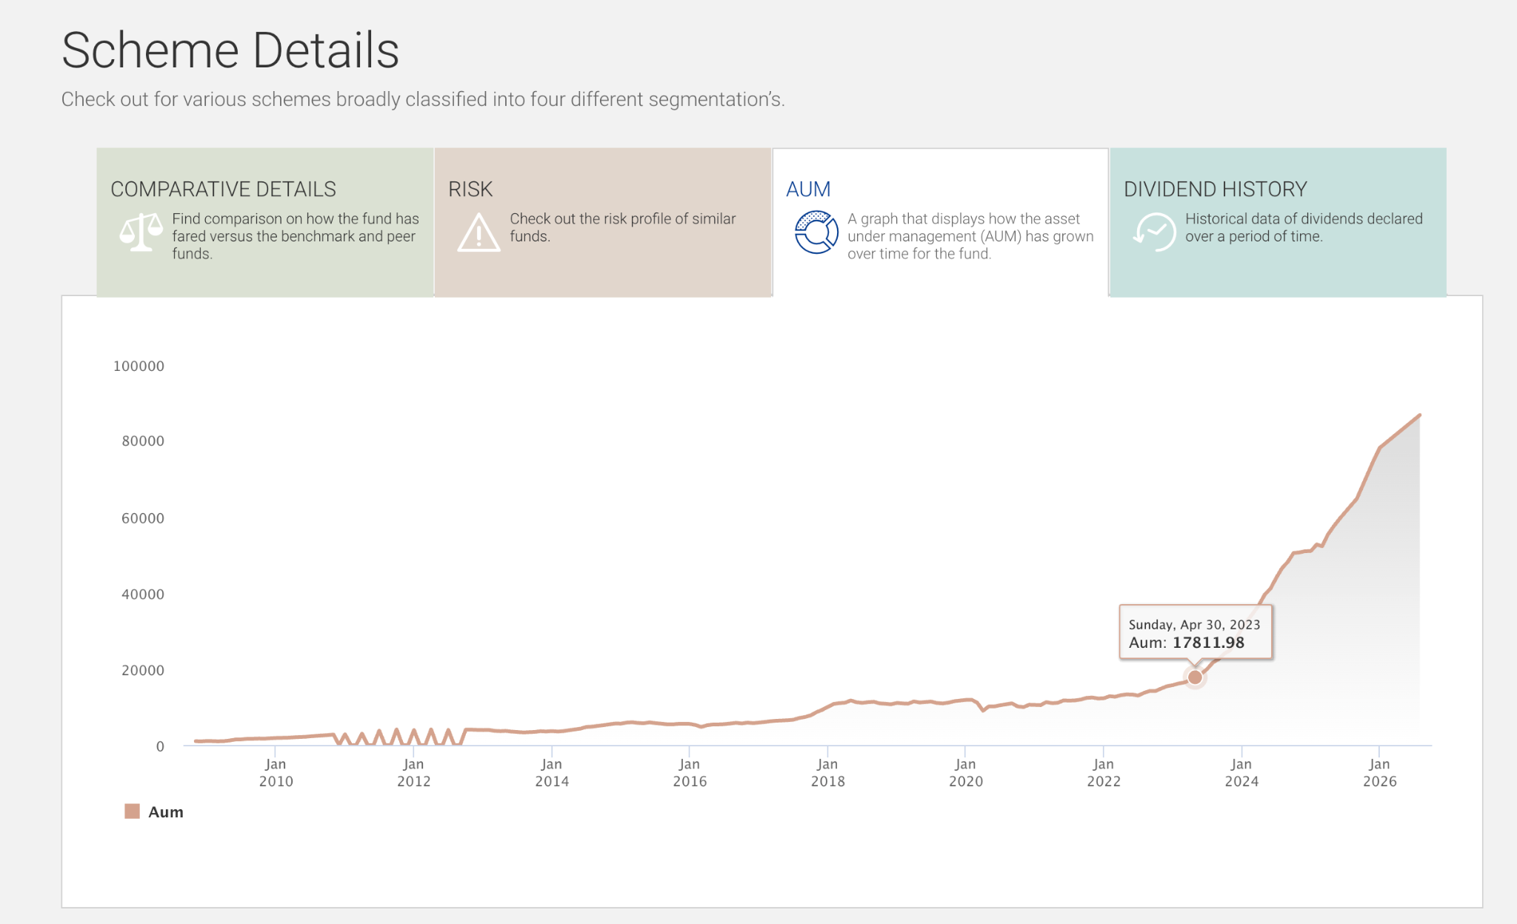
aum increased , because of gold inflation only preivous it wasn't, and so if weantt o invest in gold do in gold or if not want then not do.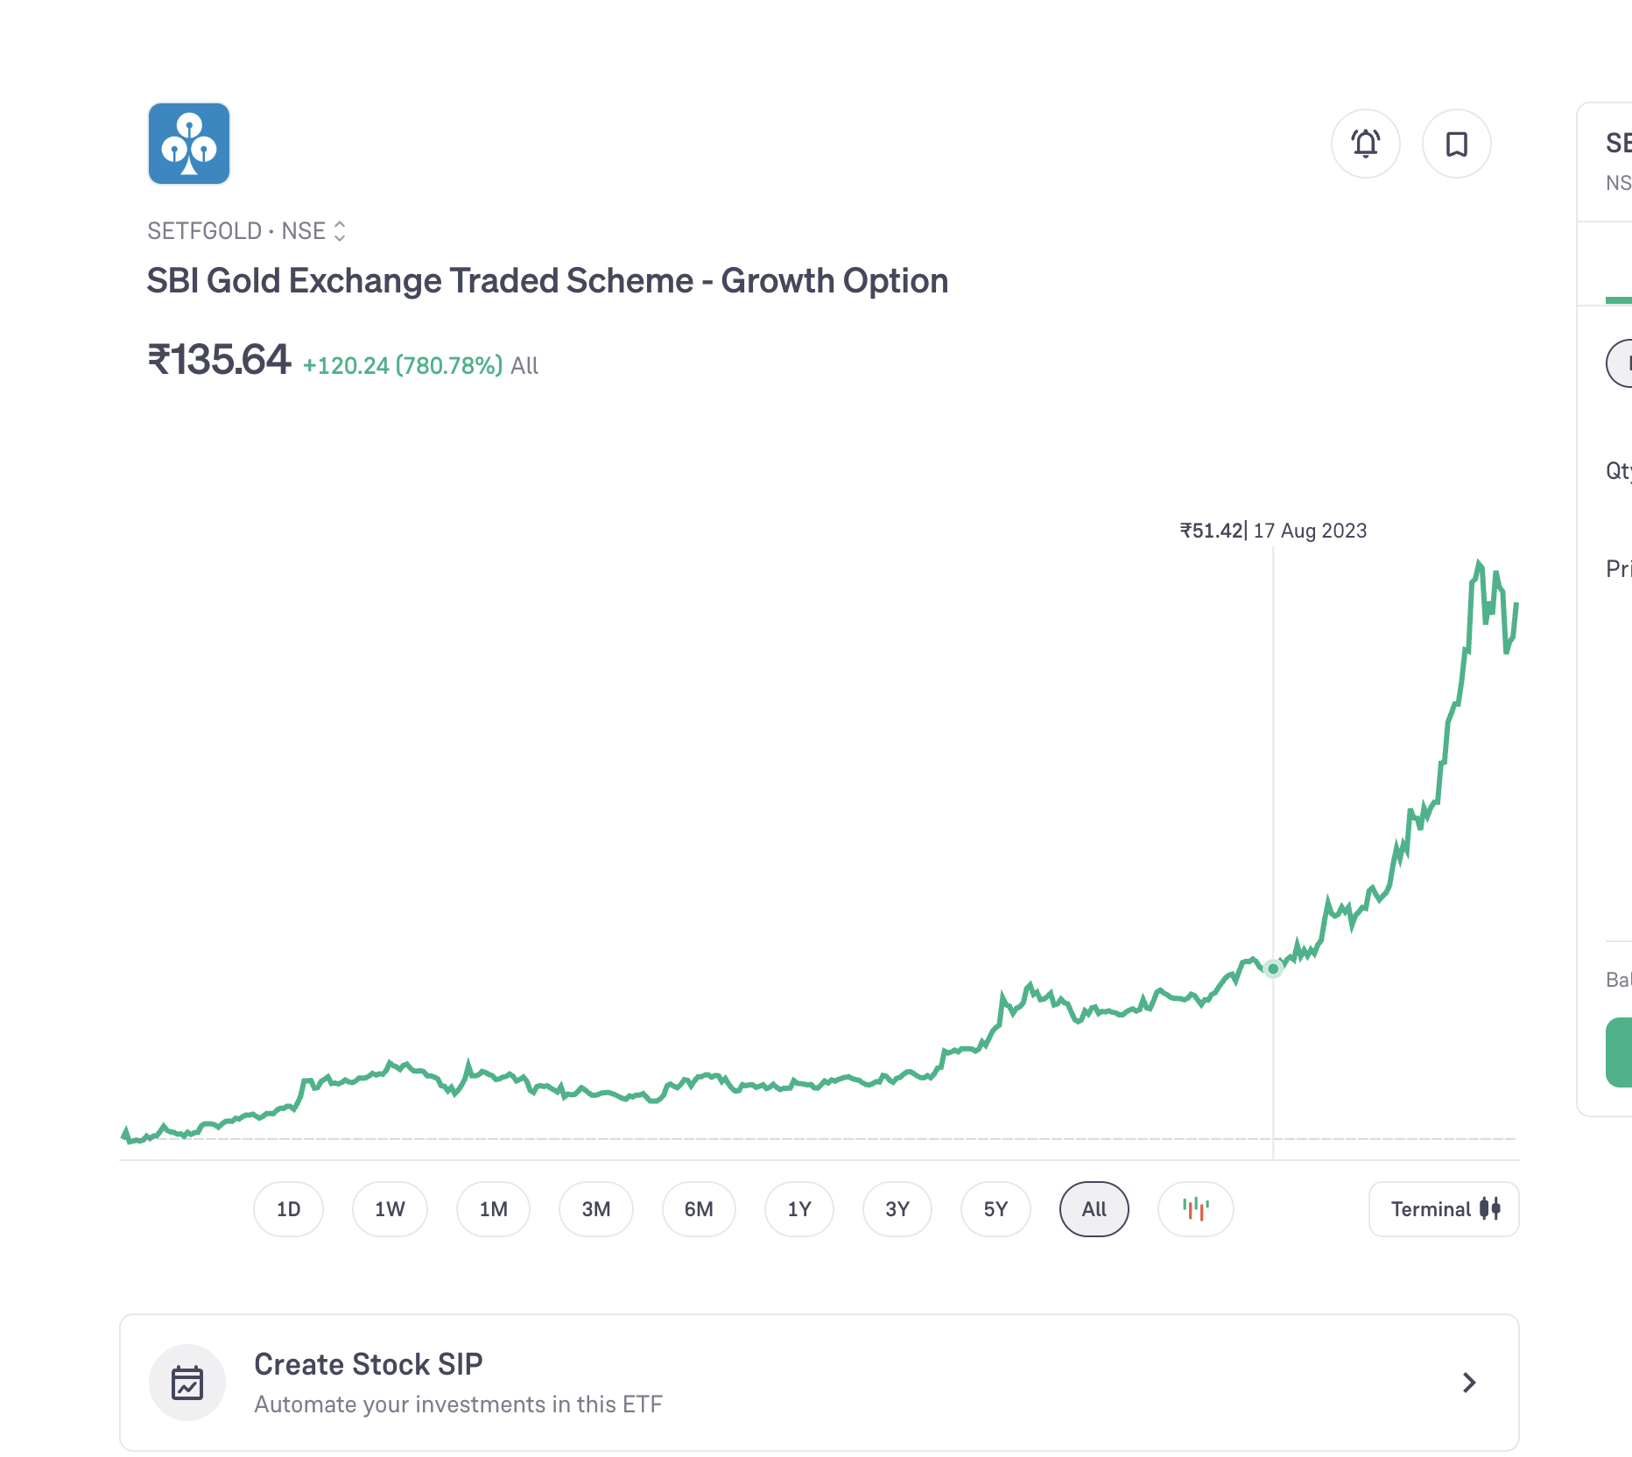
Not able to decided in rolling 10 year parag parikh definitely outperform hdfc etc. hdfc in general perform good in last trailing it perform good. i am bit baised toward parag, due to current low price getting and past history.
Phase 1 stratedy:
- Start investing in parag parikh, taking it as large cap in future not very high expectation but assuming bit better than icici large cap. ( later explore more actual flexi, hdfc flexi etc more experience ) and aum also increasing , perople complain but also adding money . 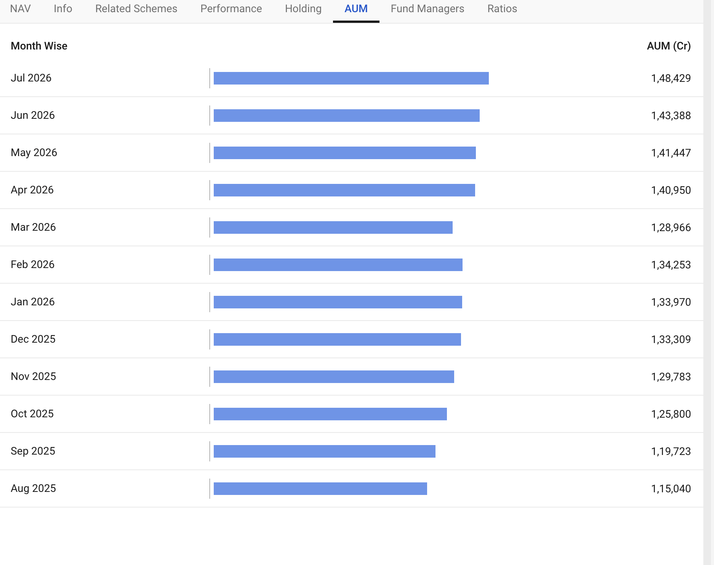
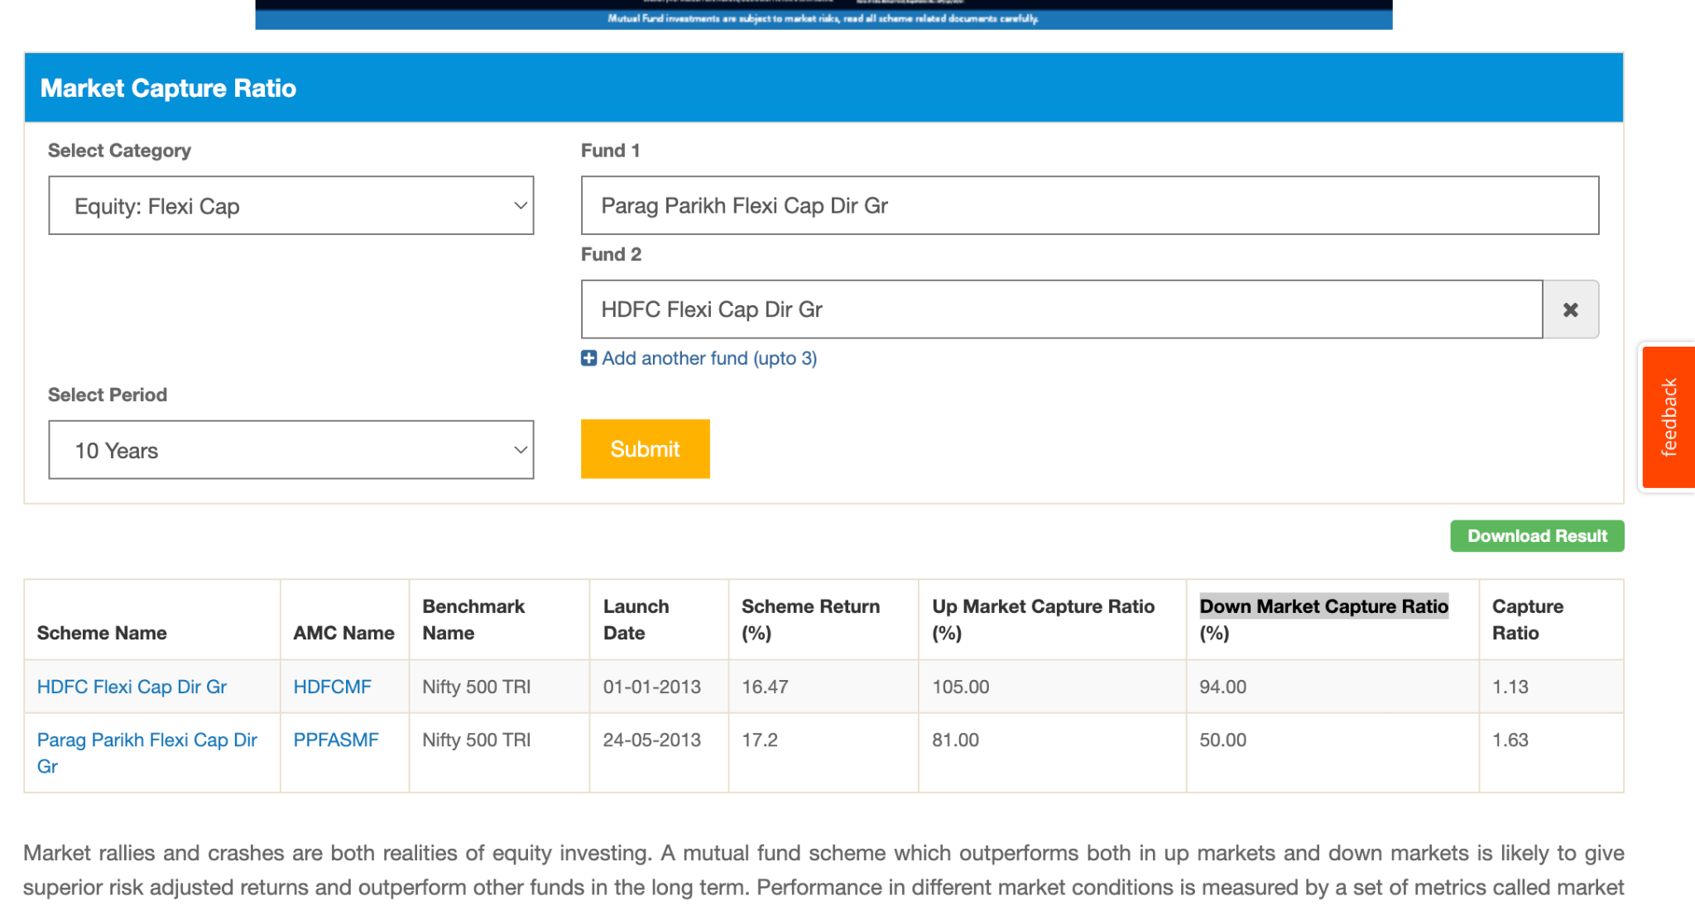
- icici large cap ? -> they have 35% overlap , out of 72% ( indian equity ) , since they have 11% overseas. As of now lets ignore. 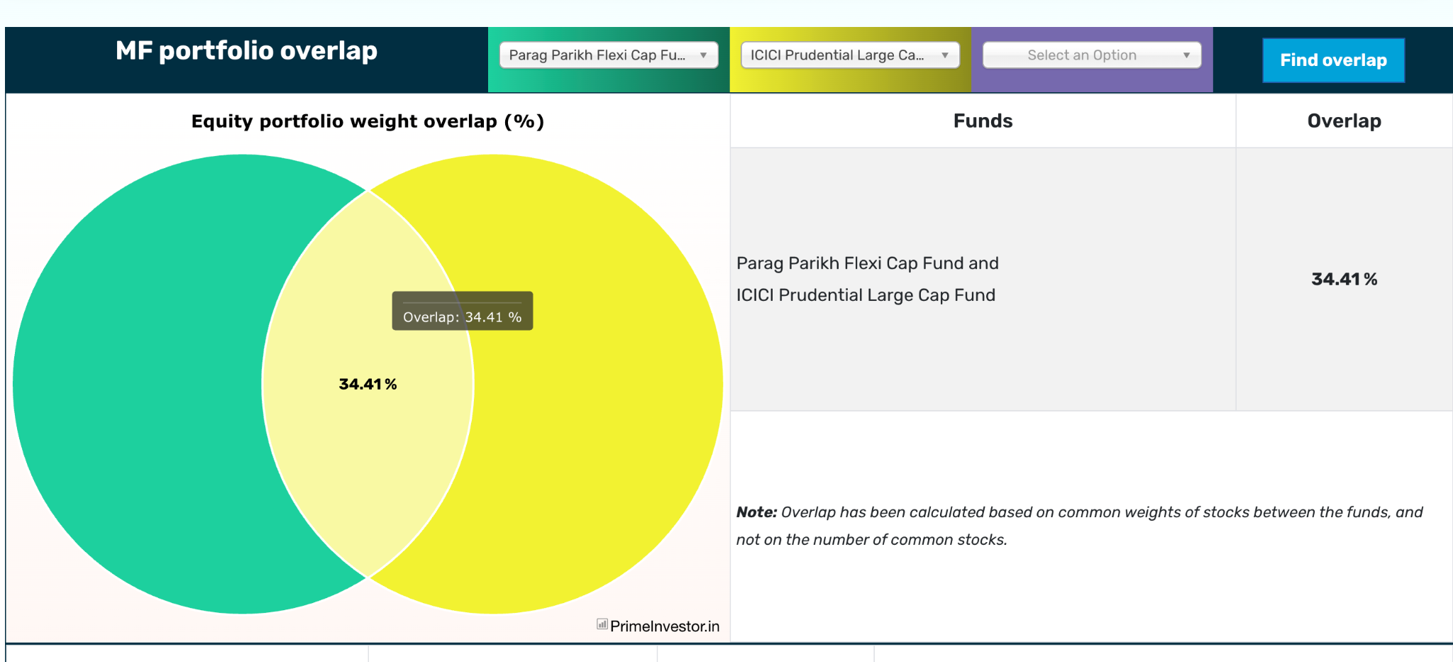

- uti nifty 50 -> no as of now.
- icici multi asset -> no as of now, when i want to invest in gold i'll do.

- midcap ( 2-3 mid cap max ) -> https://www.valueresearchonline.com/learn/equity-funds/how-many-mid-cap-funds-should-you-hold-in-a-portfolio/ :
- it's tough, midcap 150 index is less active, it's consistent, but hdfc and nippon are one of them. also if we see capture ratio: its 85-87%. ( nippon, motilal oswarl ( this has less overlapping with hdfc, proper mid cap 80% ), hdfc, nipopn midcap 150 index, motilal oswal midcap 150 )
- first from nippon and hdfc
- 31% common equities.
- hdfc is a good fund manager.
- hdfc high AUM ( 2x )
- both are garp -> blen category
- up market capture -> nippon, down -> hdfc ( not much diff )
- before 2020 hdfc was doing better, now nippon ( not different that much bit of )
- nippon ( 66, 12, 22 ) , hdfc ( 66, 22, 12 ) , ( mid, large, small )
- allocation: hdfc top 4: financial, healthcare, consumer, technology.
nippon: financial , industries, consumer, healthcare
- 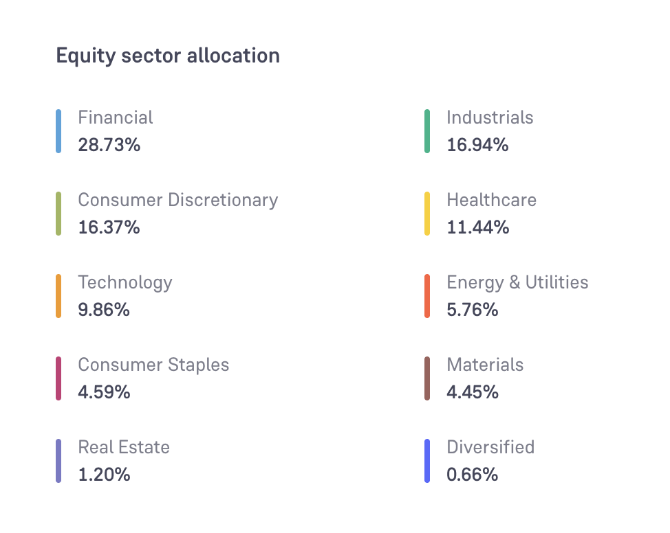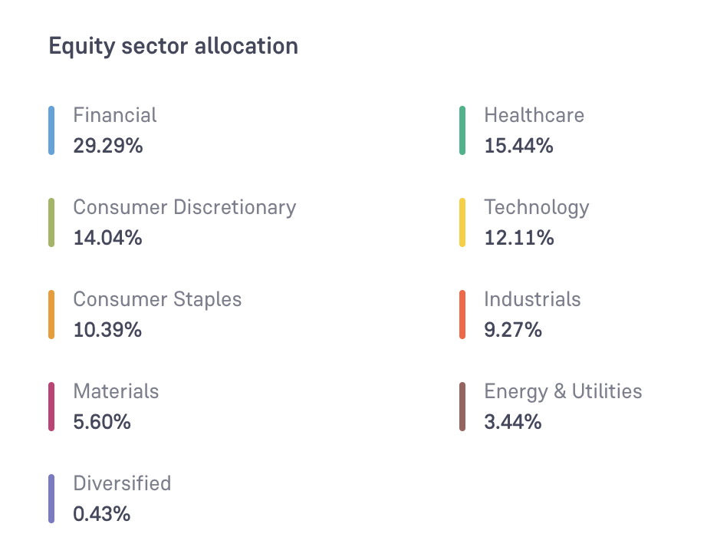
- hdfc: better down side capture ratio ( safer relatively ) , nippon better upside.
- as per past hdfc is relativel more consistent than nippon:
- nippon relative more volatile then hdfc: 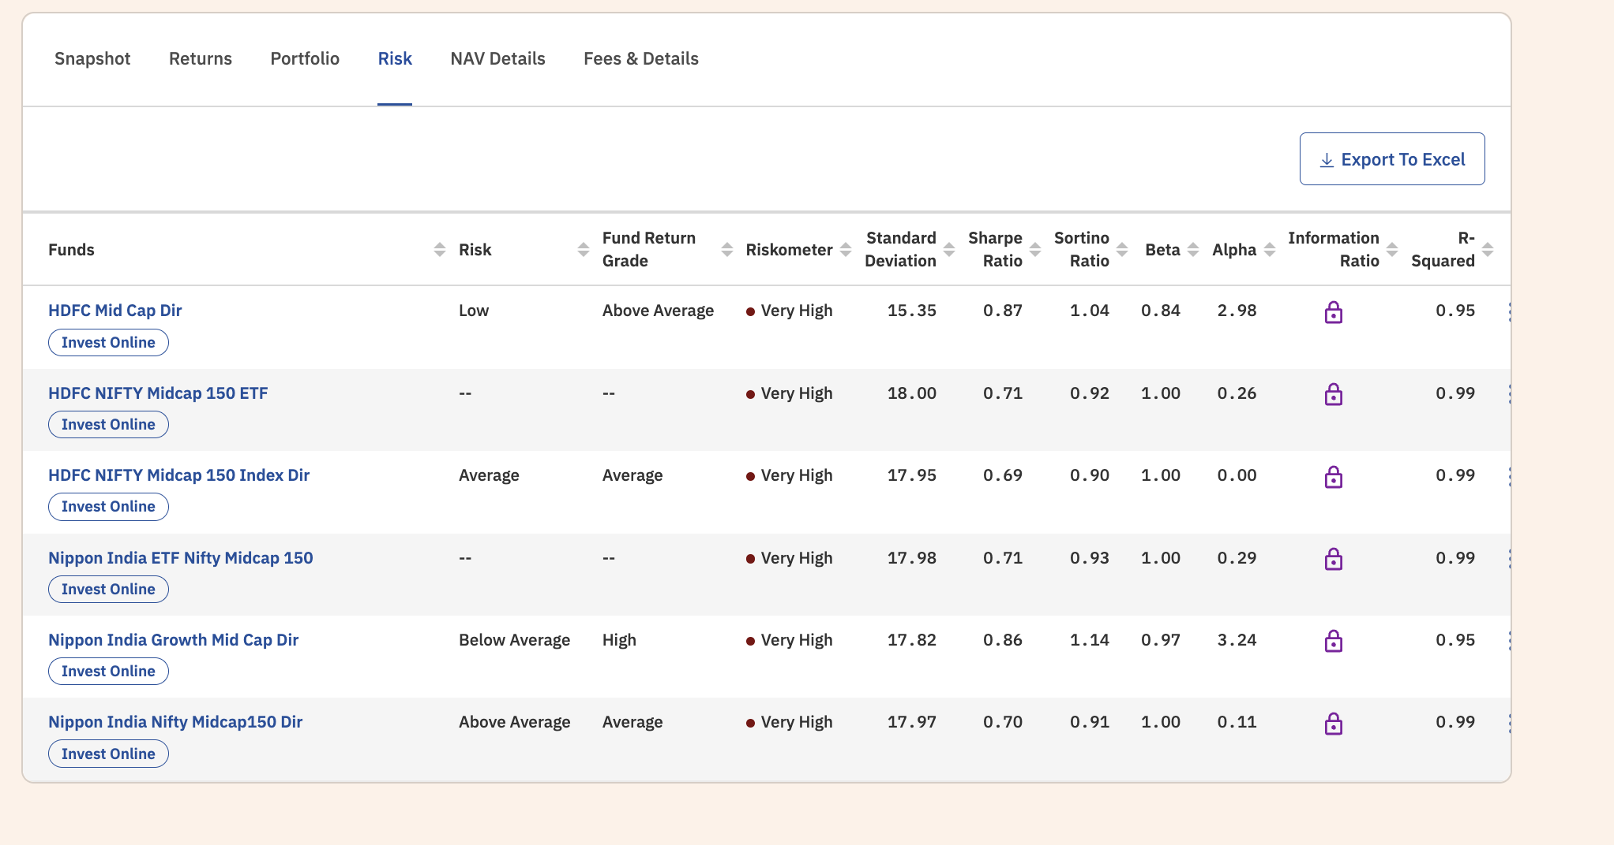
- hdfc( low risk, above abv return ) . nipon ( abg, above avg return )
- not able to get past portfolio pattern of alloation, hdfc lsat 6 month kind of cose to 65.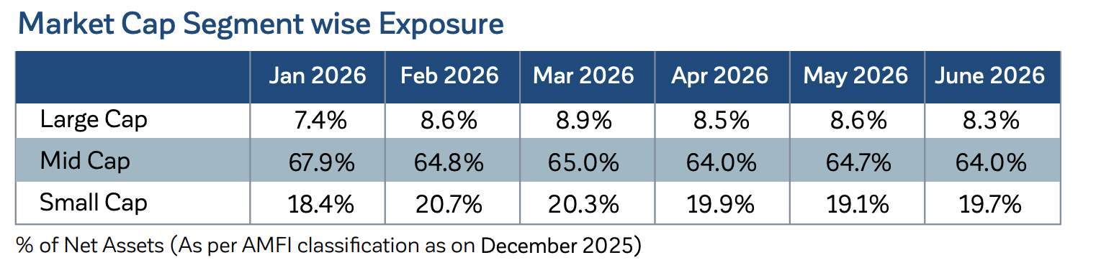
- hdfc mid can invest in overseas also ( kim ), as per rule nippon also but not explicty mention . both current doesn't have any.
- portfolio turnover: 2.6 -> hdfc , 12 -> nippon
- both are for min 5 year.
- p/e ratio more or less same. ( give idea better not to take both , but not sure)
- hdfc exit load 1 year, nippon 1 month -> both 1%
- but hdfc has bigger aum ? problematic ? , but nippon also has 52k
For now, going with hdfc first, i don't have much reason to reject nippon except , hdfc taking bets on healthcare and tech, has stronger manager, more long term, better down capture, bit less volatile. light after learning much might change ( also both have high overlapping , have same mid %, not sure about future, ppf overlapping only 1 with hdfc mid cap ) . hdfc also best only 55% out perform :smile -> link , in 10 year 99%
Active:
- Pros:
- change to generate more return as compared to index.
- have 35% protection , in down side manager might go with large or any other category to save downside
- Cons:
- what if it's not able to beat the index ? or perform worse ?
- what if it continues to do so ?
- how to know where to switch ?
- how to know which will perform well ?
- The biggest risk is performing the worst as compared to index.

Let's see how the worst perform the worst in the last 6 years. analyse how worst they can go then
- aditya birla sun life is a failure. [ VR article ]badly(same for 5y and has 6.5k crore), in 10y ( -3% always ) , before covid was close to benchmark after that far away.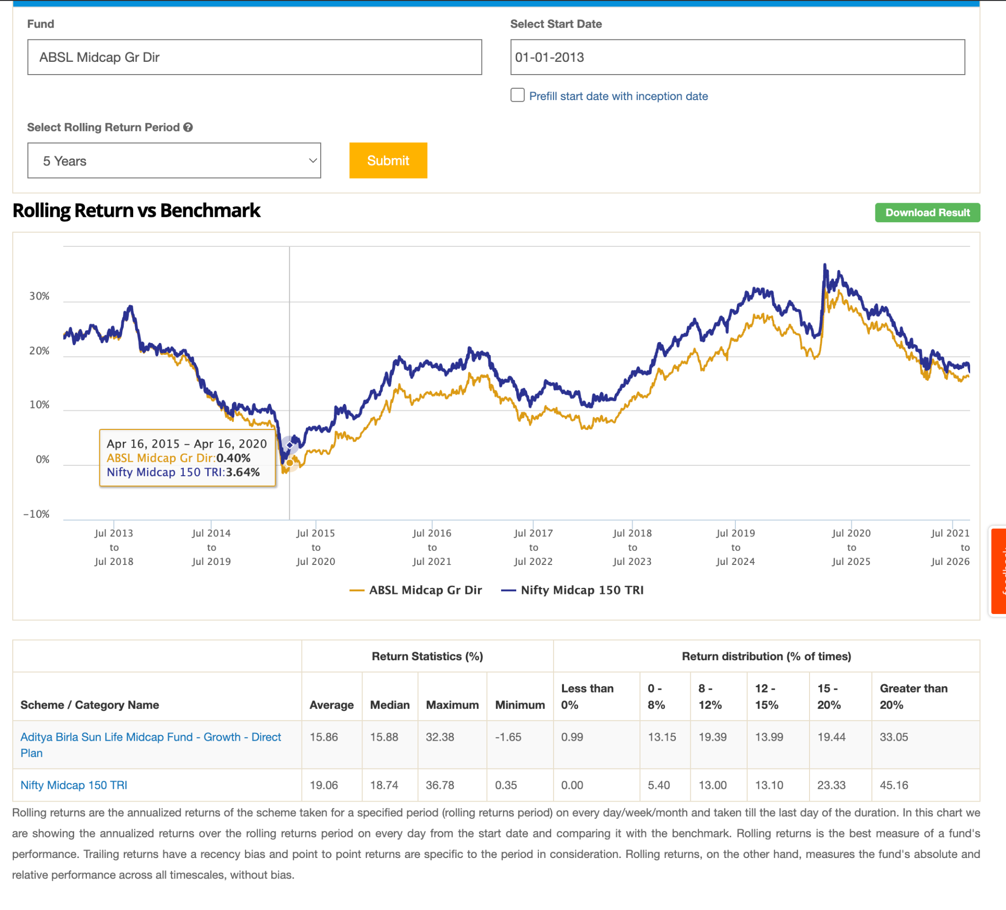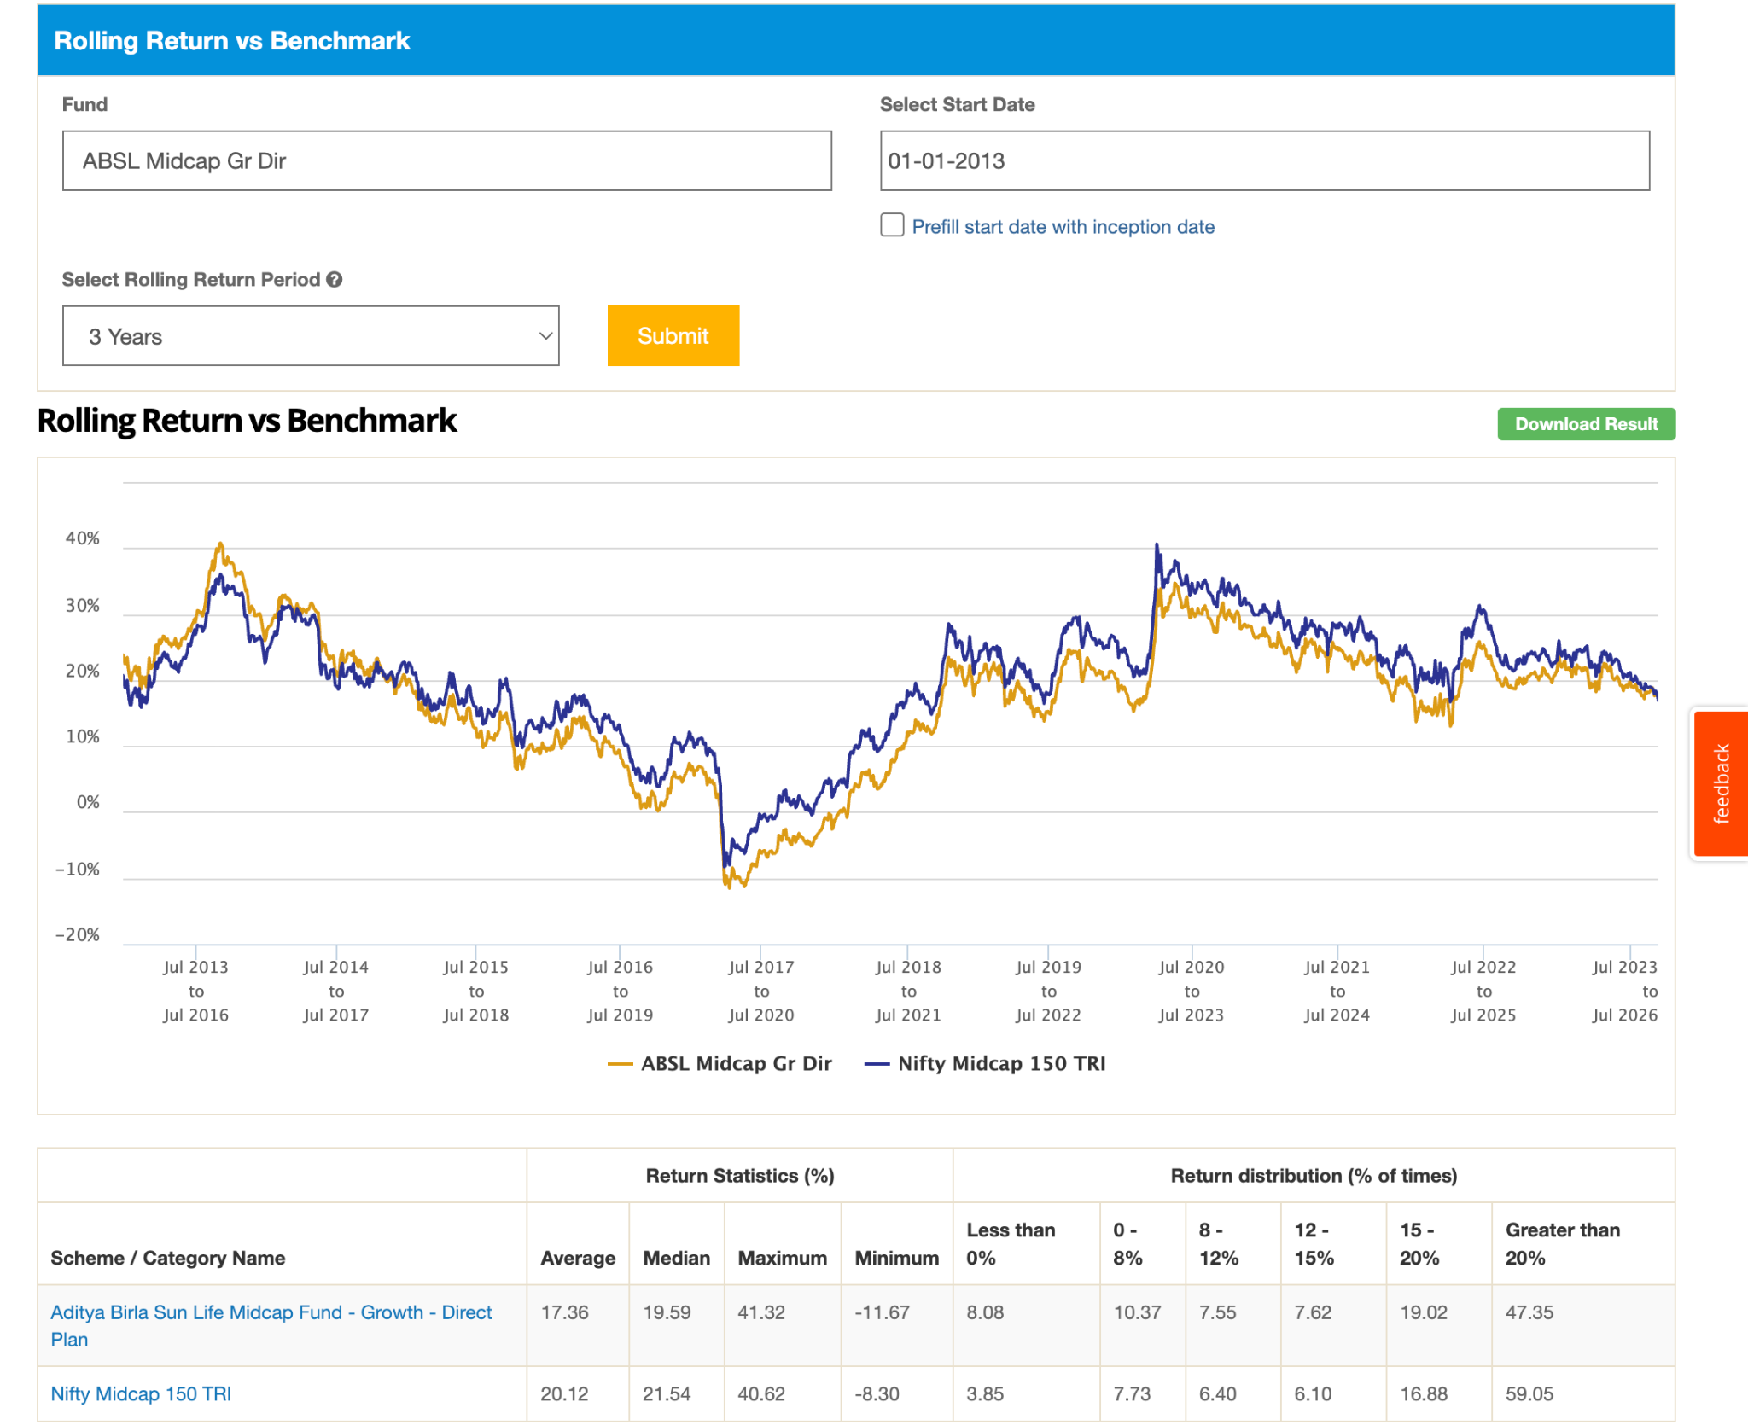
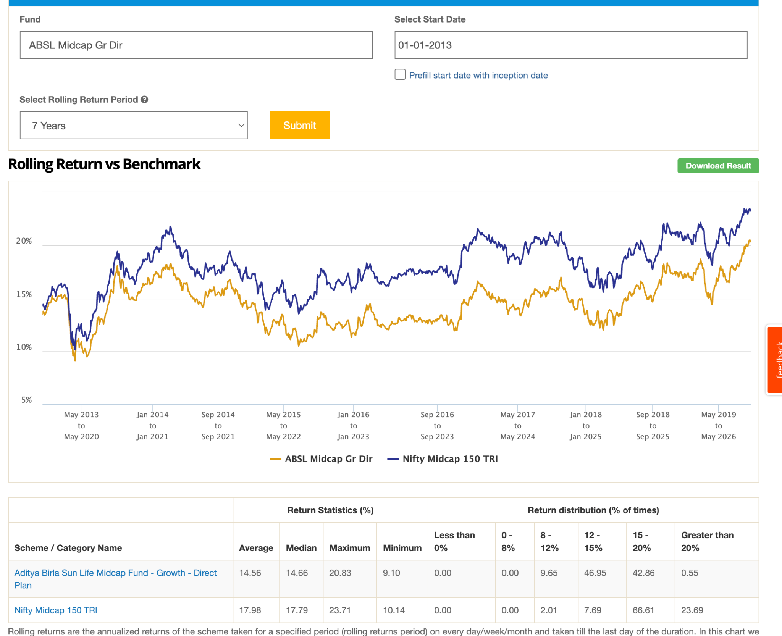
- Franklin India Mid Cap Fun ( 12k ) , after corono something bad happen thats's why not able to see in 10 year return as compare to hdfc, and in 5 year have less. 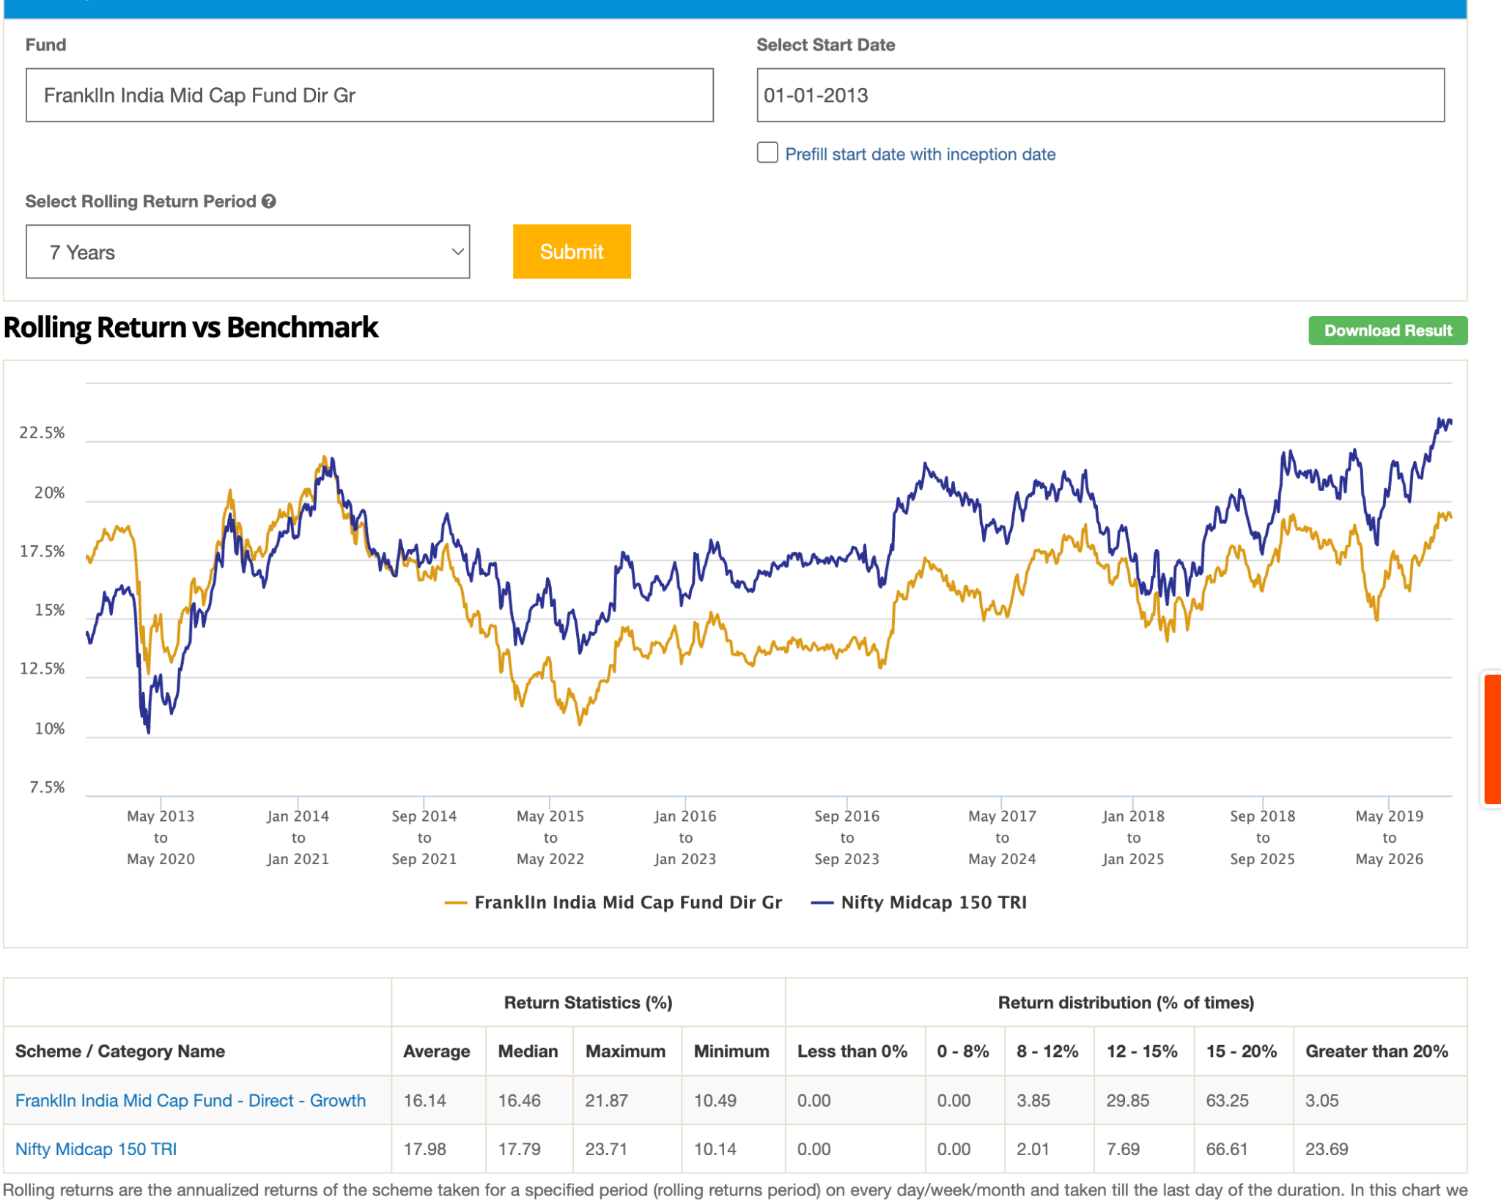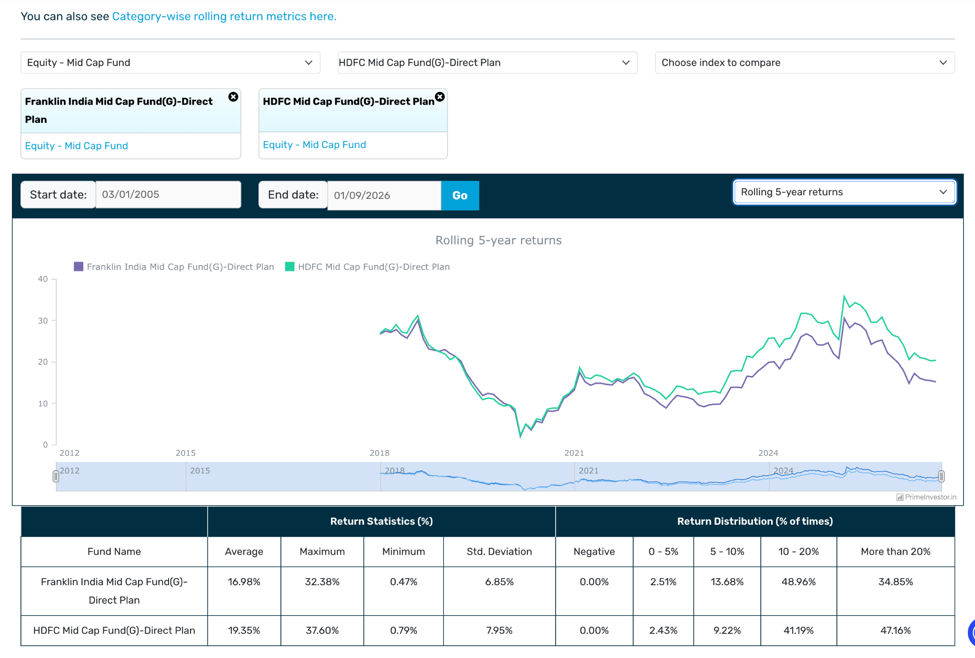
- LIC MF Midcap Fund -> <500 aum and its 9y old, perform badly at starting never beat index. same for 7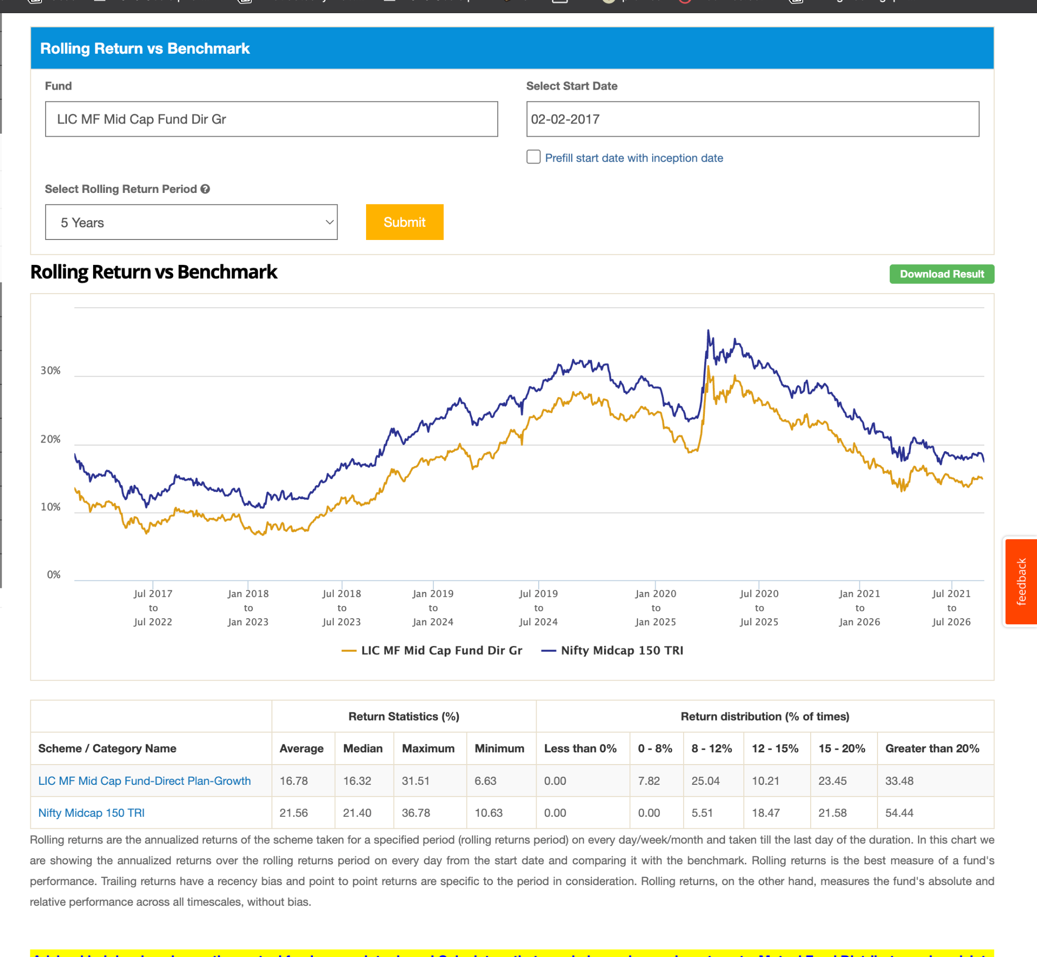
- UTI Mid Cap Fund ( 12k ): this is also not able to beat index before corno as well ( for some time only )in short time like 3y, while long yes before.: same for 5,7, 10 years.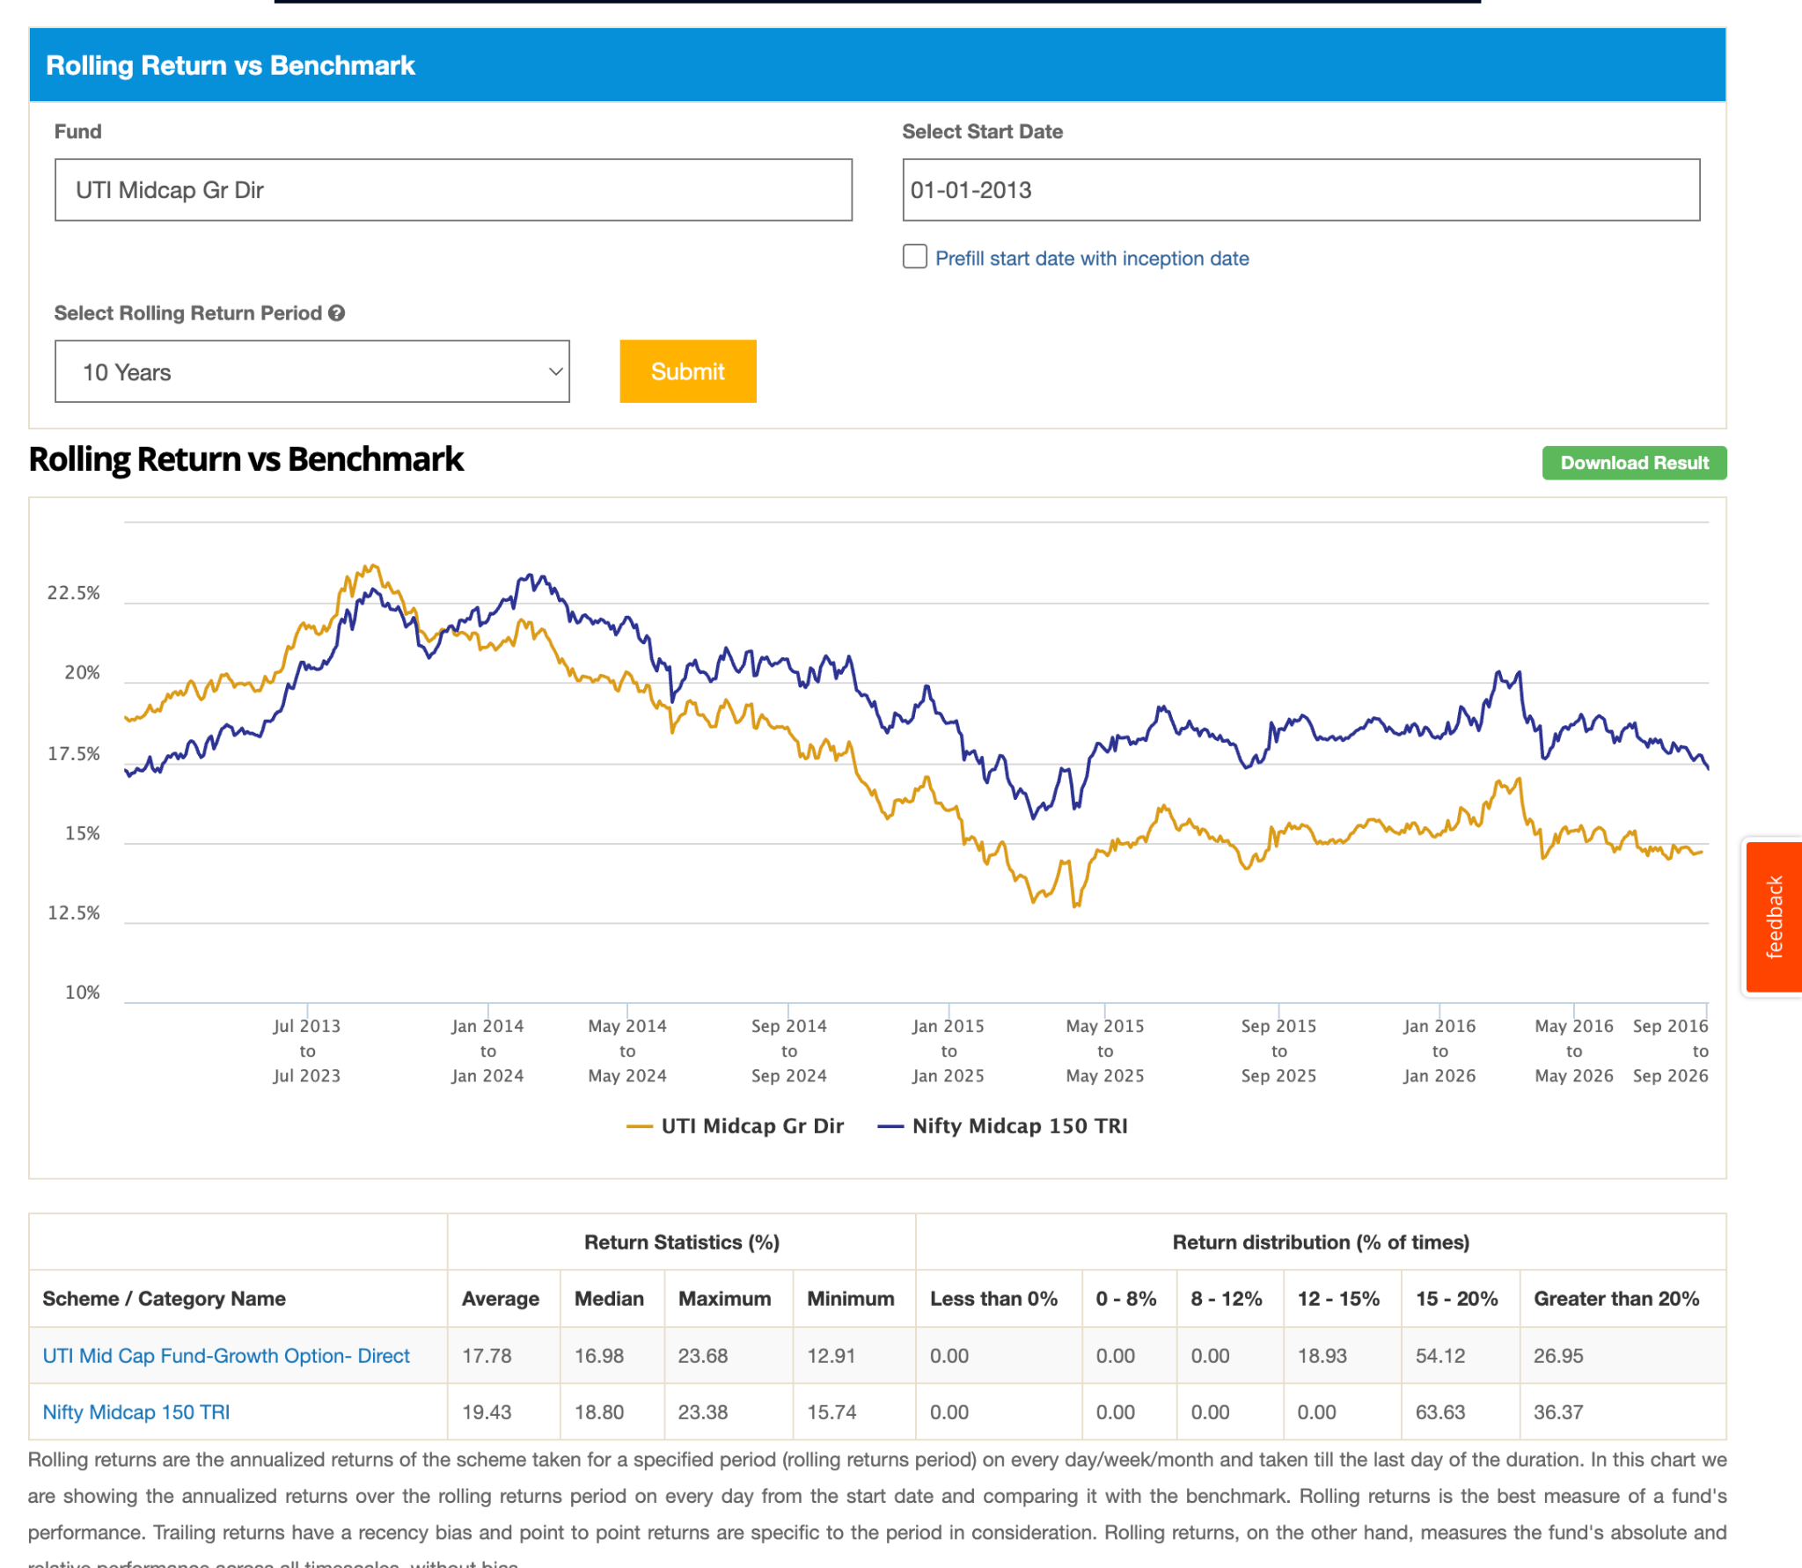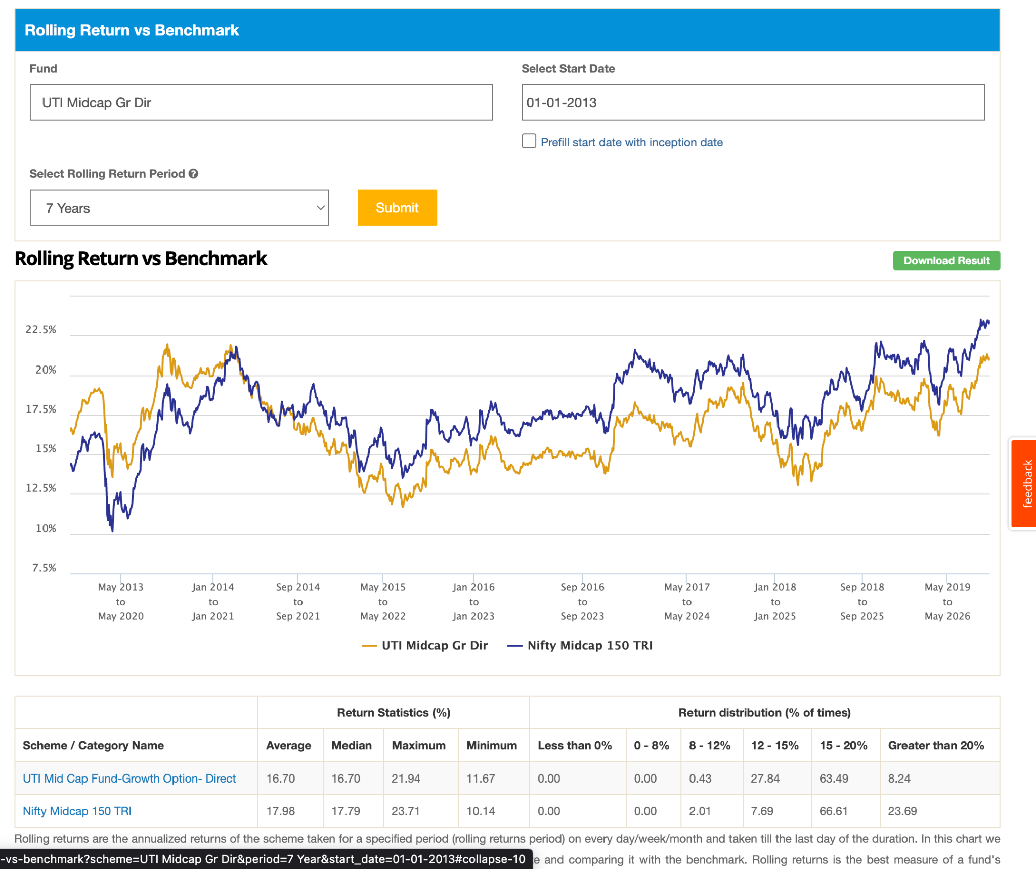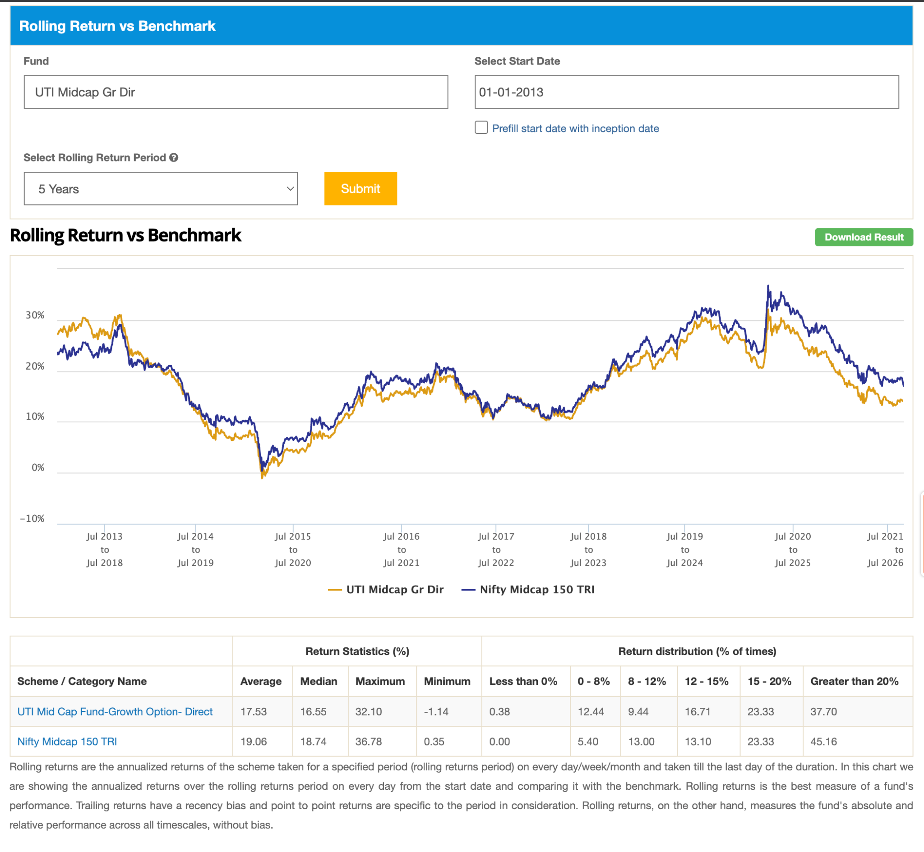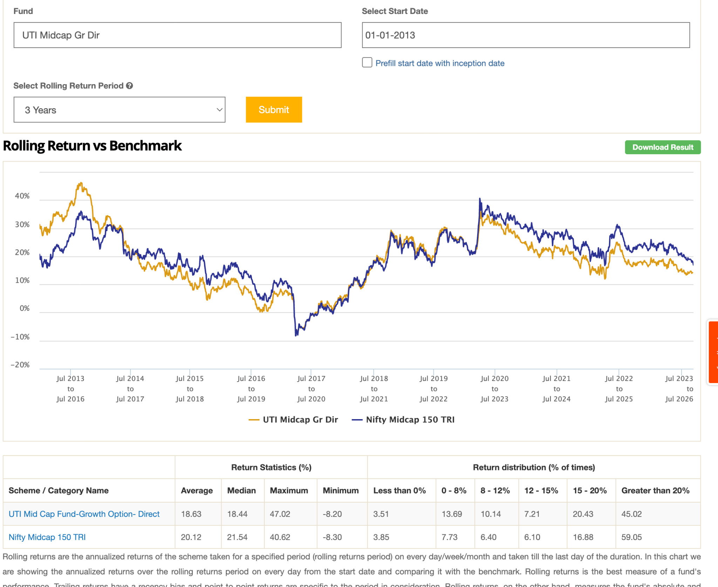
- Taurus Mid Cap Fund -> ( 150cr ) -> worst ignore this not sure what happending with this.
- DSP Midcap Fund ( 20k ) -> same like other after corono not able to beat index
- so tldr: above gave around 14-17 or below 2-5% than index, in worst case which is equal to taking some hybrid funds.
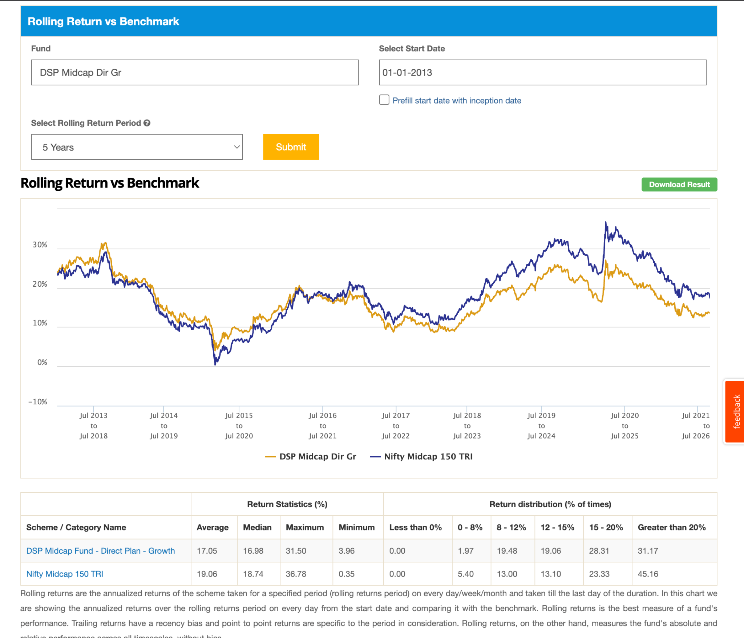
In short if you are in the worst MF , then you'll have 2-4% of loss as compared to index , also downside capture > 100 , upside < 100. if marking giving 18 -> you might get 14%. like -31 index => -34
- Category 2
- JM Mid Cap Fund: ( 1.2k ) its new 4y, so in this category ( beating)
- WhiteOak Capital Mid Cap Fund: ( 6.8k ) its just 4y old so in this category beating handsomely: 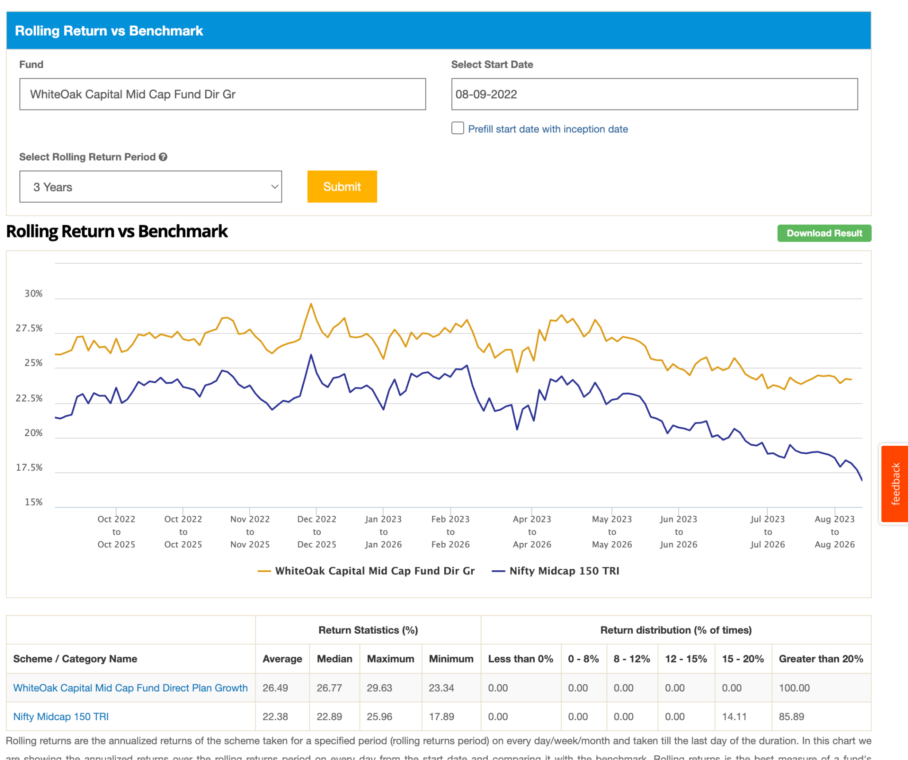
- PGIM India Midcap Fund ( 11k ): in 10 year its not able to beat any time: ( but instead of 3-4 its 2-3% -ve )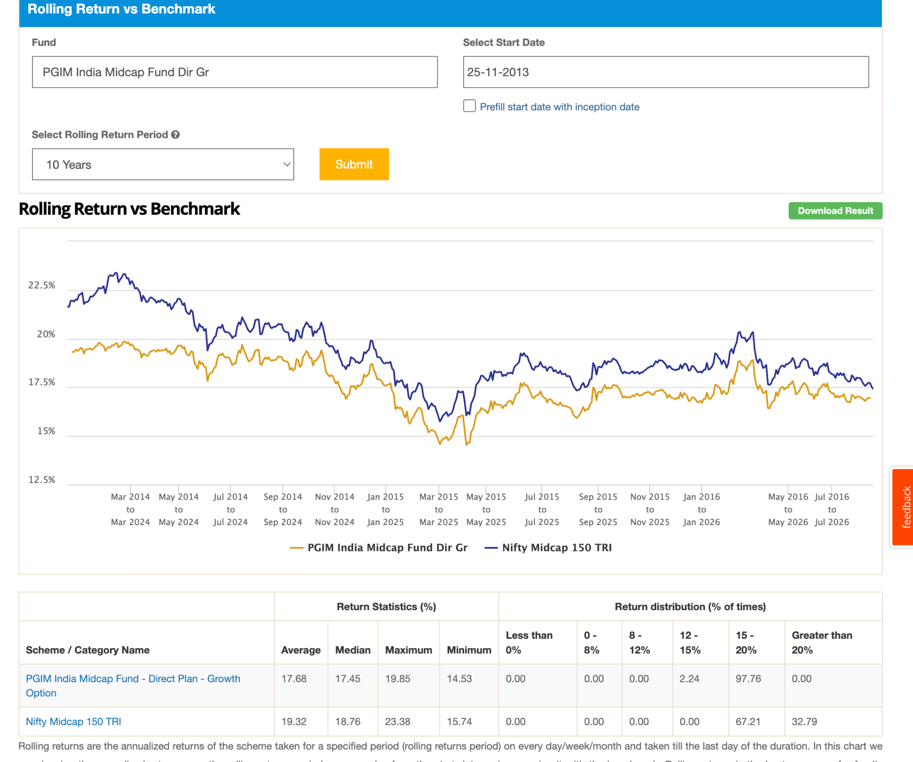in 7 and 5 year. in 7 mostly was able to beat in 5 partial, not able to deliver after crono and at starting. 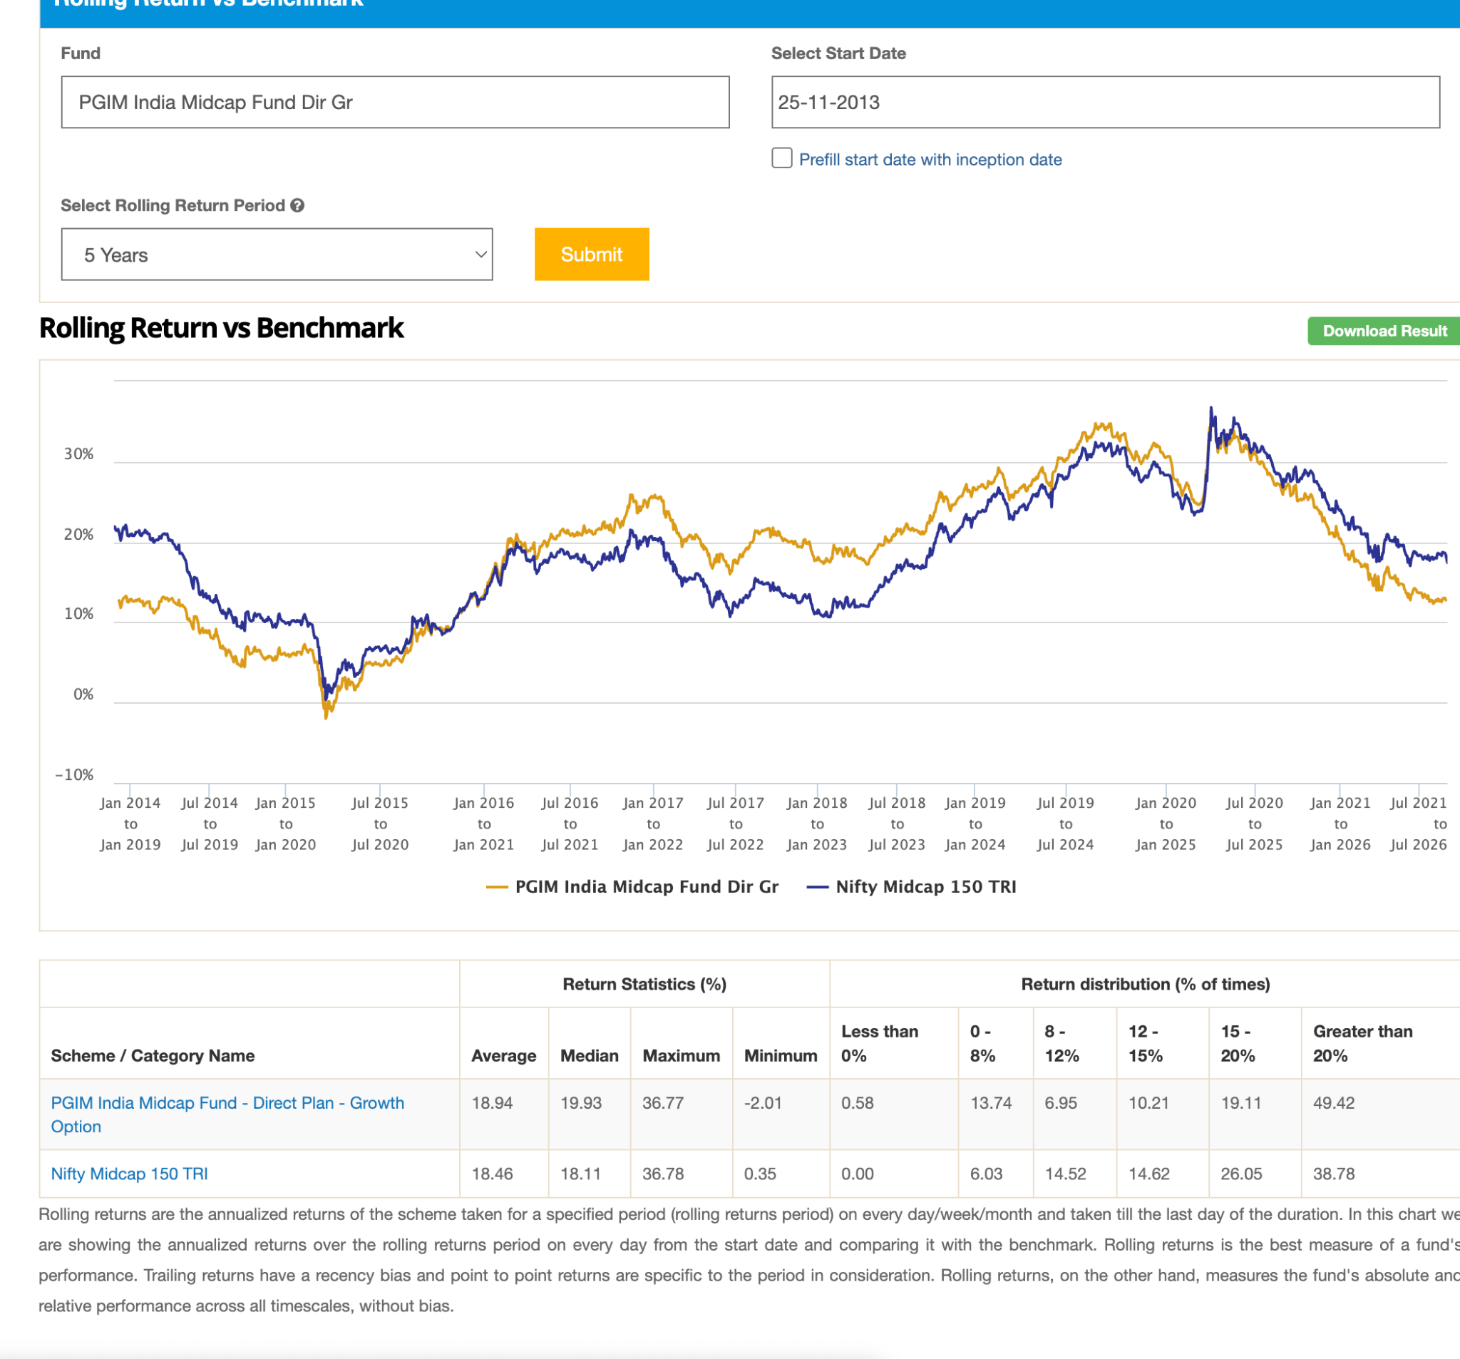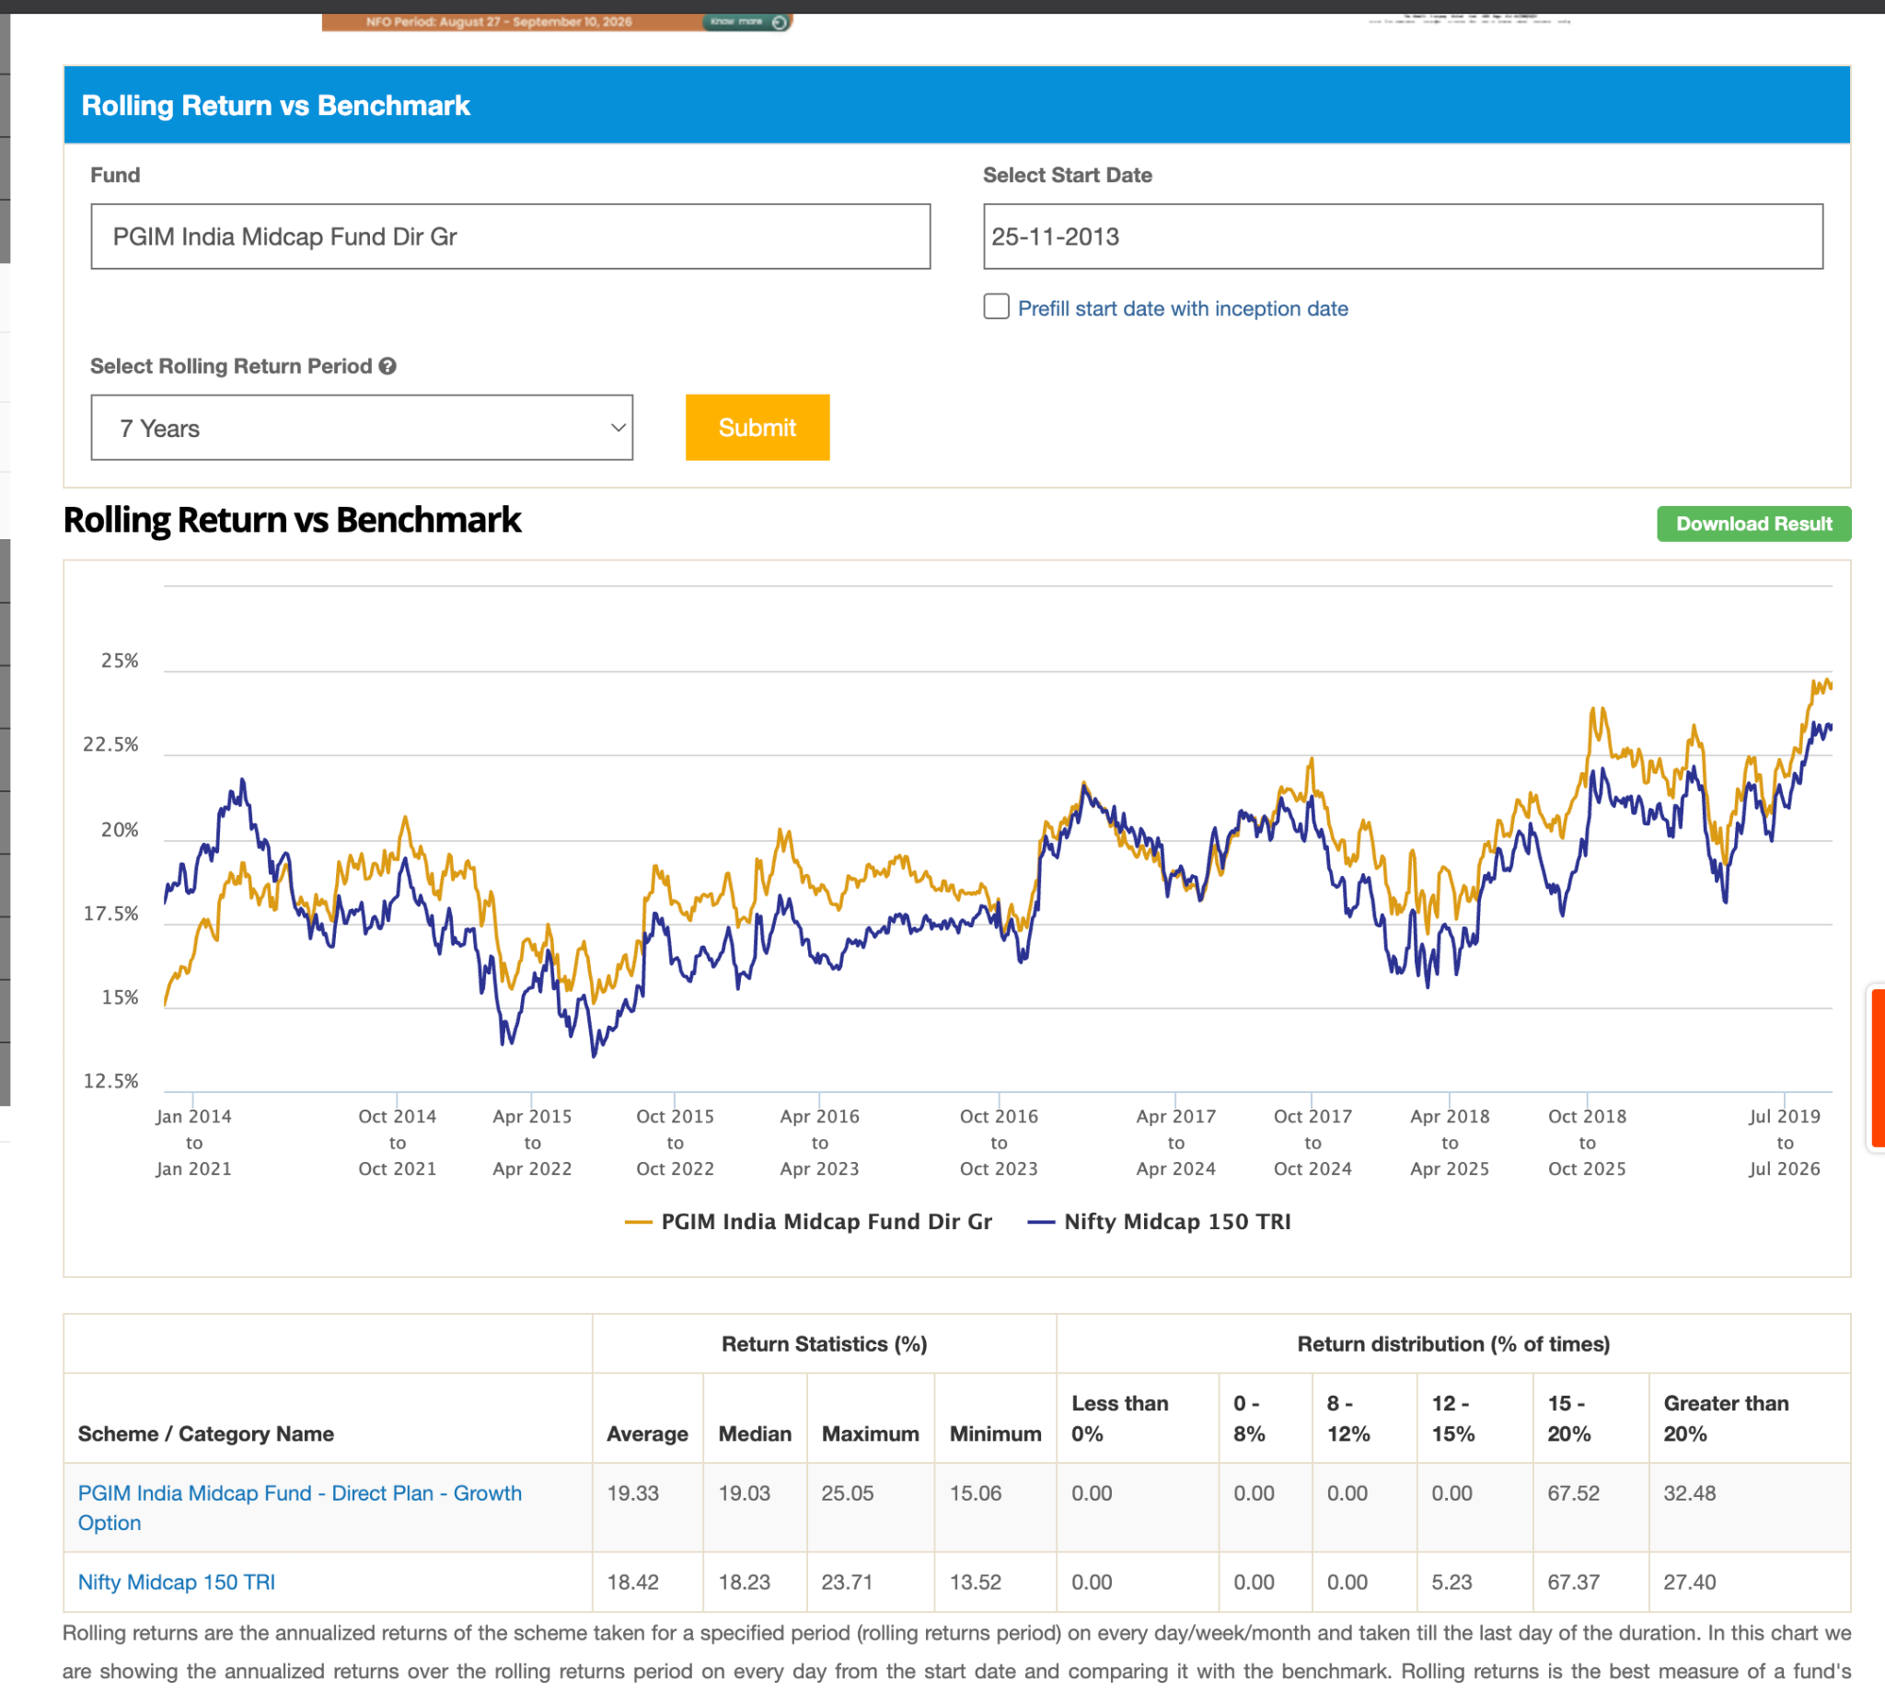but return wise in 5,7 its not like very downgraded.
- SBI Midcap Fund: (24k ) , not able to beat after 2024 in 10y, in short not able to beat in 5 and 6 , but not always down,but most of the time and most of the time it's very close to index. 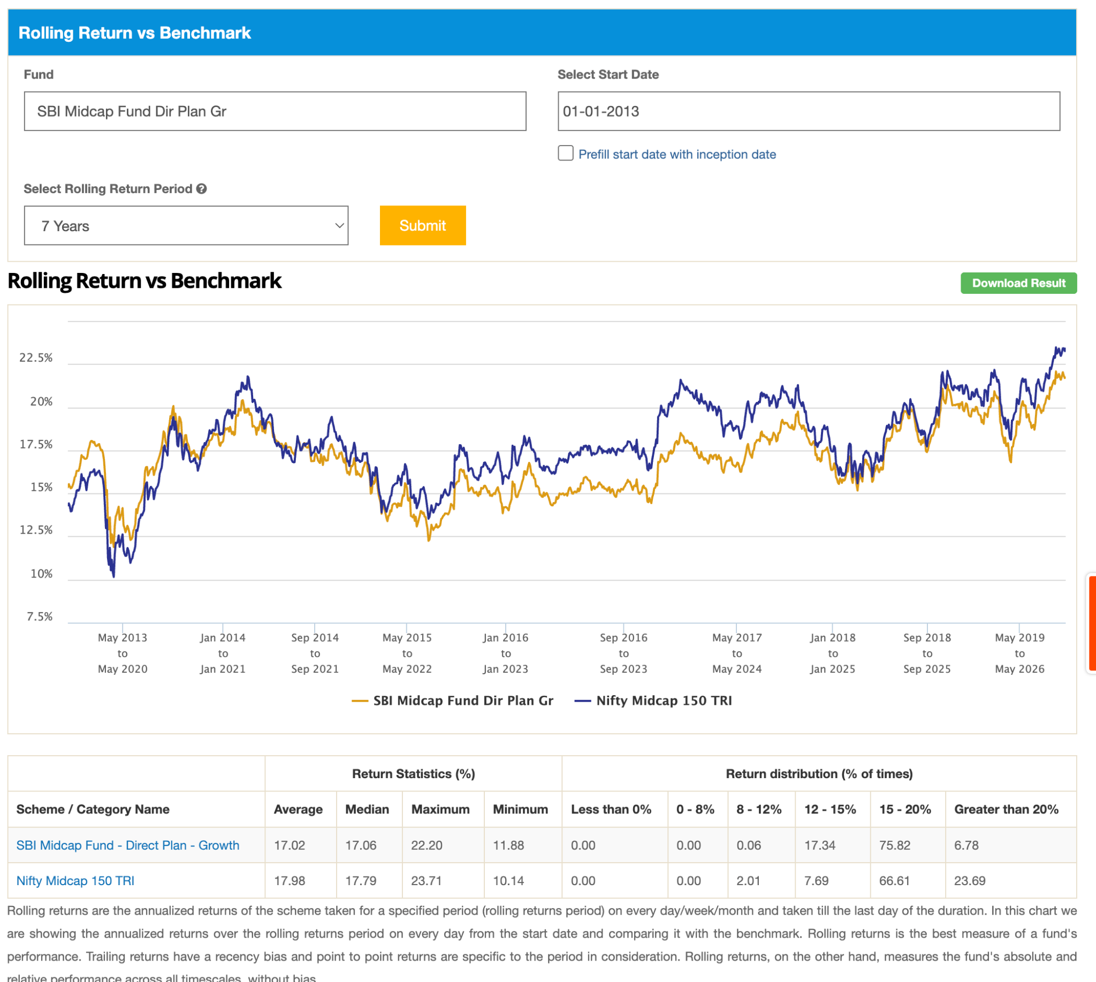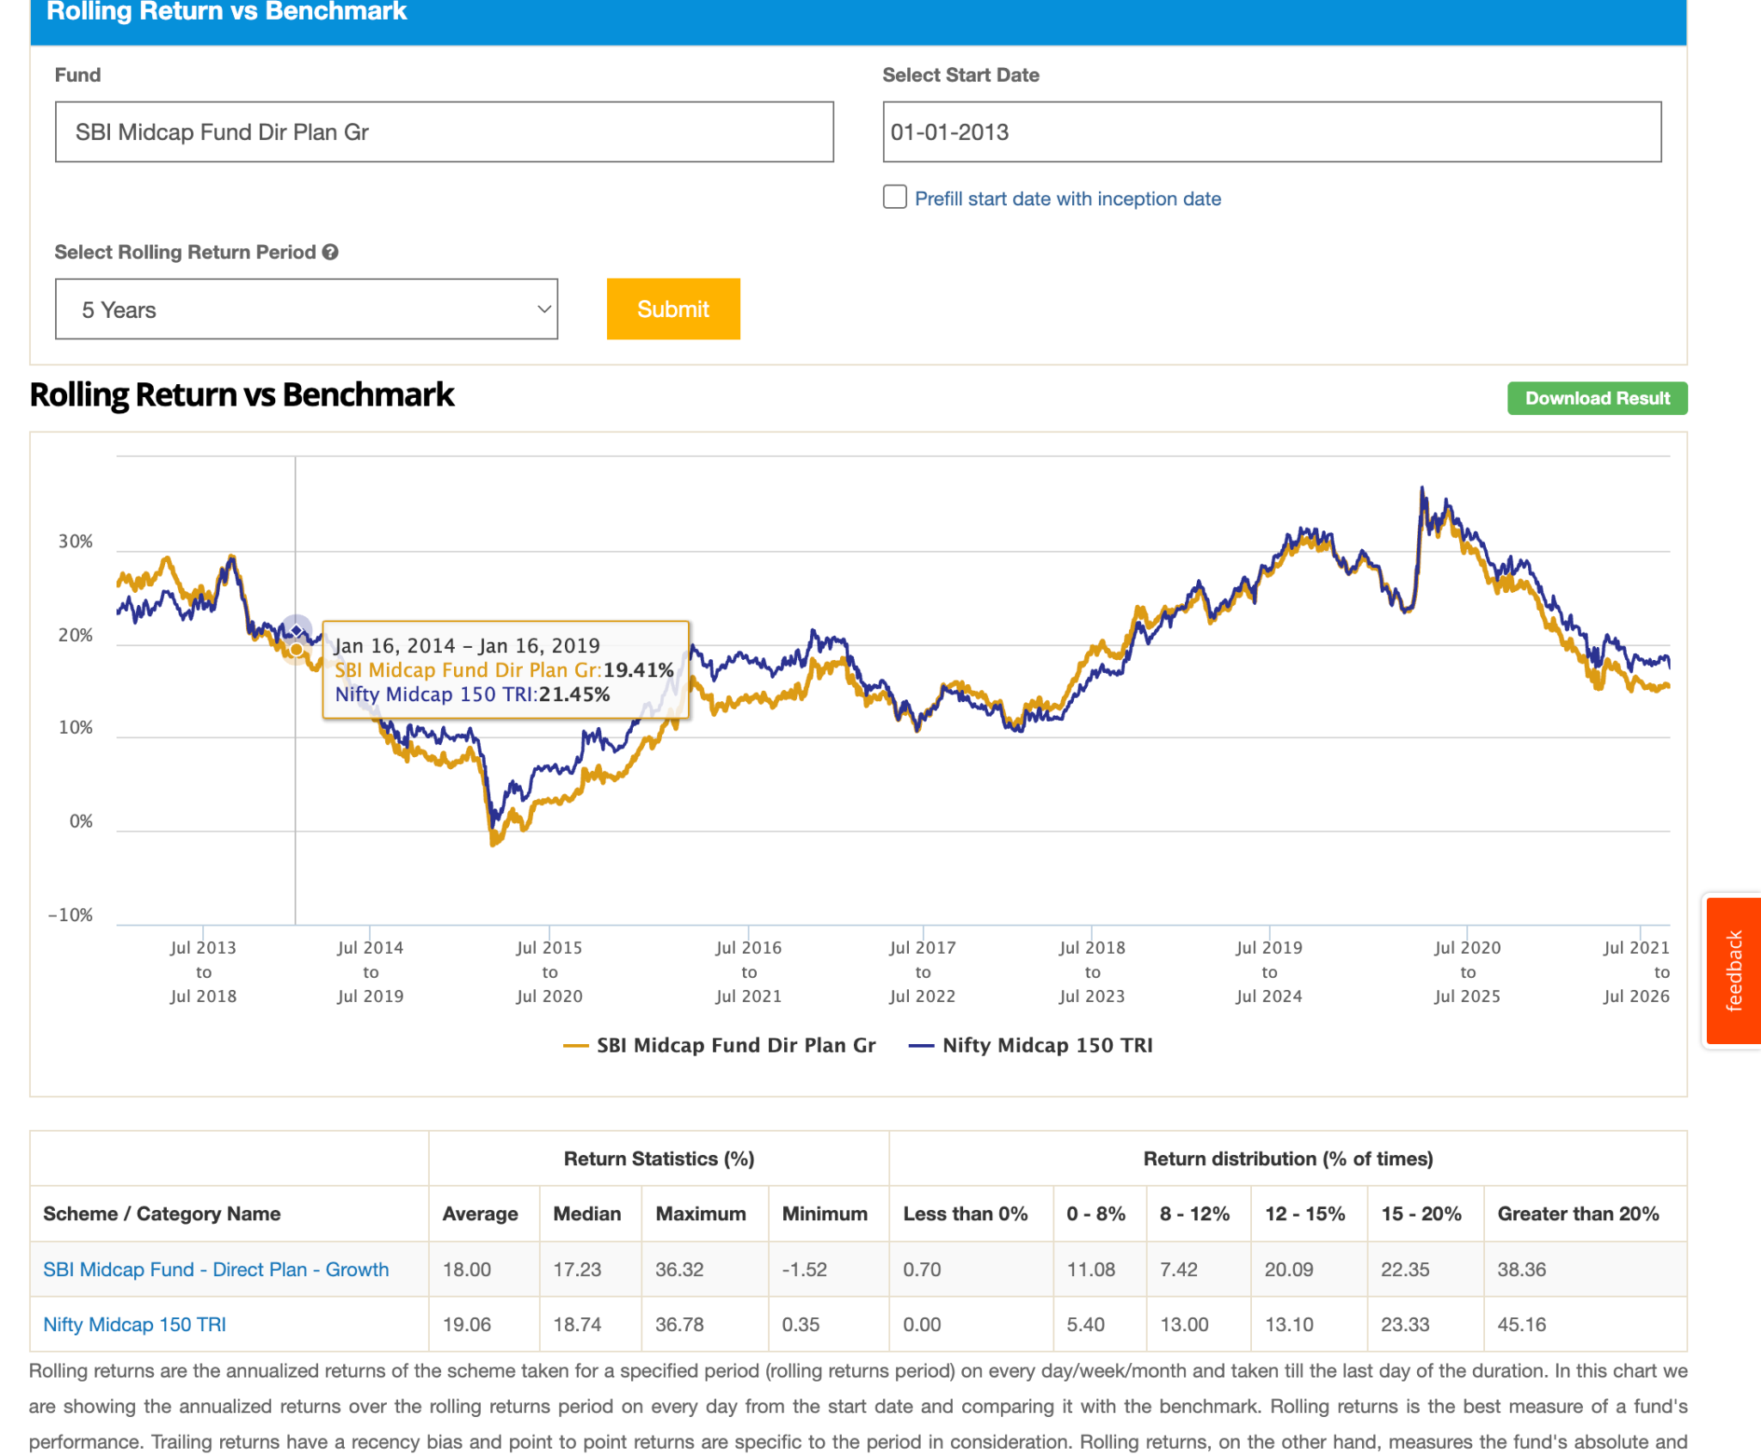 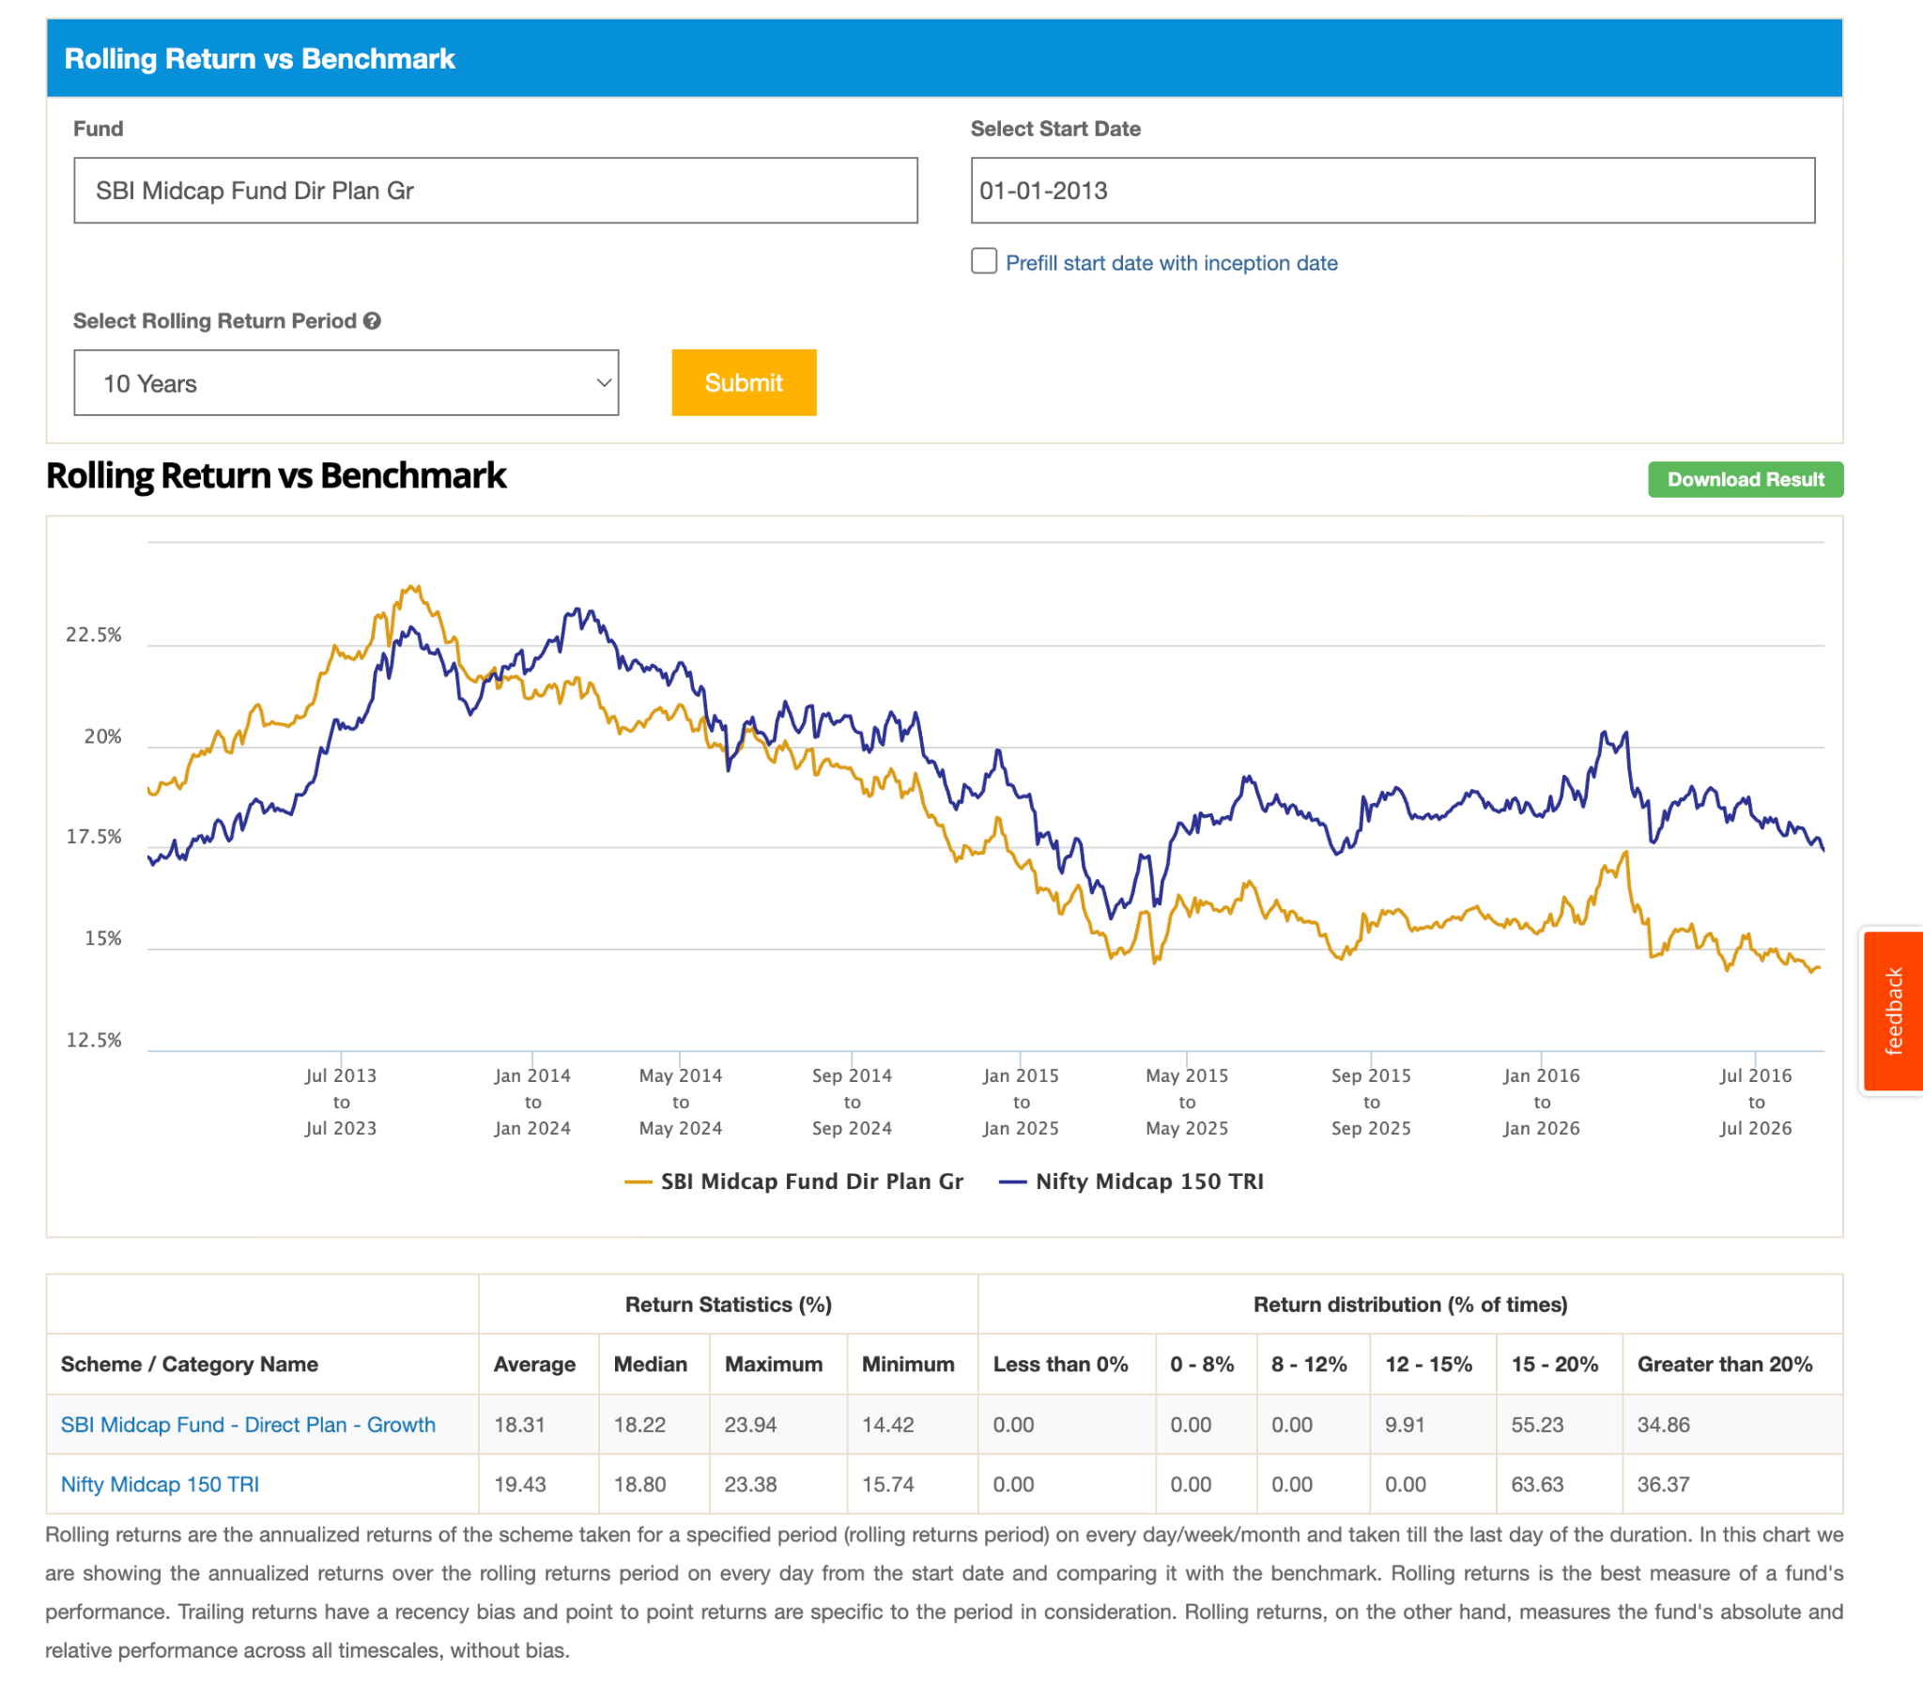
- Union Midcap Fund: ( 1.8 6y ): ( moved to the worst category ) : it performed better, tried hard but was not able to beat the index :) but not bad. bascially won't be sad to take this. if this not doing good not did too worst.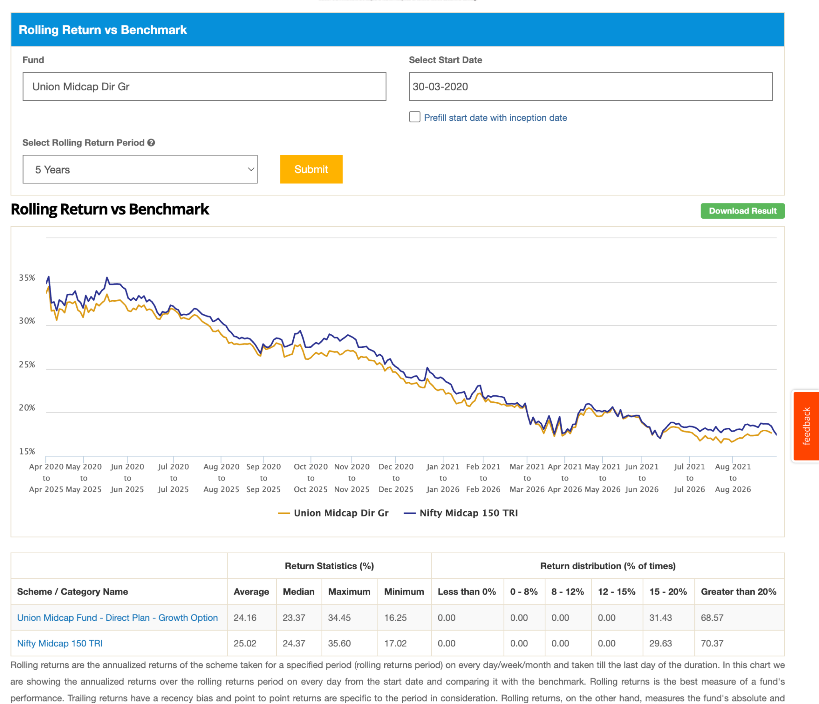
- Tata Mid Cap Fund: ( 6k ) : after 2024 not able to beat in 10y, in 5y before corno cut to cut after corno bit below . 7y 50% of time 